Hi everyone,
I hope that you all keeping well. This week we are looking at 3D shapes and I have included some notes and examples to help you out. Try your best!!
Mrs. Doyle

3-D Shape
Language used in this Topic
Dimensions dimensional cube cuboid cone cylinder sphere prism pyramid face edge vertex vertices

Helpful Hints
Use building blocks at home
Look for 3- D shapes in the home, garden, local environment.
Describe these shapes. What shape faces do they have? Are they curved?
Cut through different food items at home (e.g. bread, cucumber, lemon). Are all slices the exactly the same?
- A prism can be sliced in such a way that all slices are the same size.
e.g. a Toblerone

- The net of a shape is how the shape looks when you flatten it out and you can see all the faces at the same time
- Vertices = corners
- Is tetrahedron is a pyramid with a triangular base
- A prism has the same cross-section all along its length. A cross-section is the shape you get when cutting straight across an object. If the cross-section of the object is a triangle shape, then the object is called a triangular prism.

Here are some common 3D shapes that you should know.
Along with a picture of each shape, the number of faces, edges and vertices are also given.
Common properties of the 3D shapes are also given.
Cube  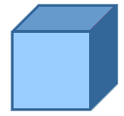 | Cubes have 6 faces, 12 edges and 8 vertices.  All sides on a cube are equal length.  All faces are square in shape.  A cube is a type of cuboid.
Cuboid  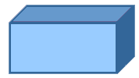 | Cuboids have 6 faces, 12 edges and 8 vertices.  All the faces on a cuboid are rectangular.
Sphere  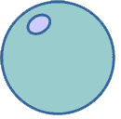 | Spheres have 1 curved face, 0 edges and 0 vertices.
Cylinder  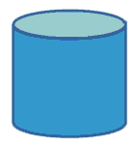 | Closed Cylinders have 3 faces, 2 edges and 0 vertices.  Closed cylinders have 2 circular or elliptical faces and one curved rectangular face.
Cone  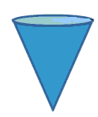 | Cones have 2 faces, 1 edge and 1 apex (which is described by some mathematicians as a vertex).
Triangular Prism  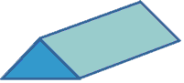 | Triangular Prisms have 5 faces, 9 edges, and 6 vertices.  The two faces at either end are triangles, and the rest of the faces are rectangular.
Hexagonal Prism   | Hexagonal Prisms have 8 faces, 18 edges, and 12 vertices.  The two faces at either end are hexagons, and the rest of the faces are rectangular.
Triangular-based Pyramid  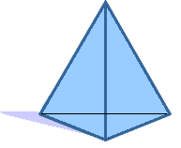 | Triangular-based pyramids have 4 faces, 6 edges and 4 vertices.  The base is a triangle. All of the faces are triangular.  If the triangular faces making up the prism are all equilateral, then the shape is also called a Tetrahedron.
Square-based Pyramid  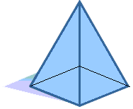 | Square based pyramids have 5 faces, 8 edges and 5 vertices  The base is a square. All the other faces are triangular.
Hexagonal Pyramid  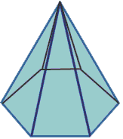 | Hexagonal pyramids have 7 faces, 12 edges, and 7 vertices.  The base is a hexagon. All of the other faces are triangular.
Tetrahedron  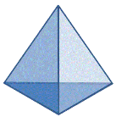 | A Tetrahedron is the same as a triangular pyramid.  They have 4 triangular faces, 6 edges and 4 vertices.  A regular tetrahedron has equilateral triangles for its faces, and is one of the 5 platonic solids.
Cube (regular hexahedron) | Cubes have 6 faces, 12 edges and 8 vertices.  All sides on a cube are equal length.  All faces are square in shape.  A cube is a type of cuboid and is one of the 5 platonic solids.
Octahedron  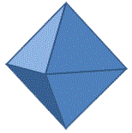 | Octahedrons are a shape with 8 faces, 12 edges and 6 vertices.  A regular octahedron has equilateral triangles for its faces, and is one of the 5 platonic solids.

Nets of 3D Shapes
Net of a Cylinder and Triangular Prism
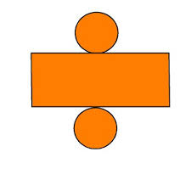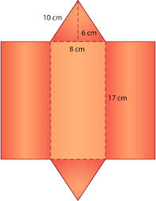

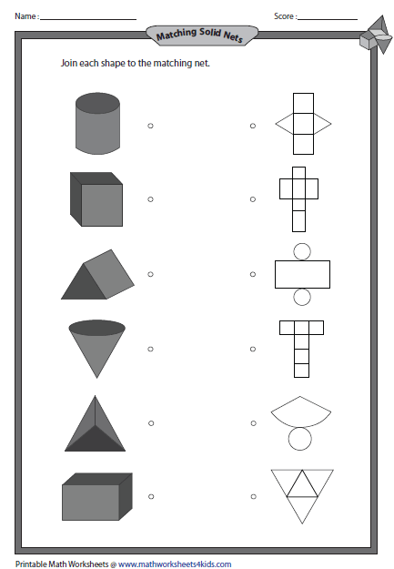

Monday Q. 1 Tuesday and Wednesday Q. 2

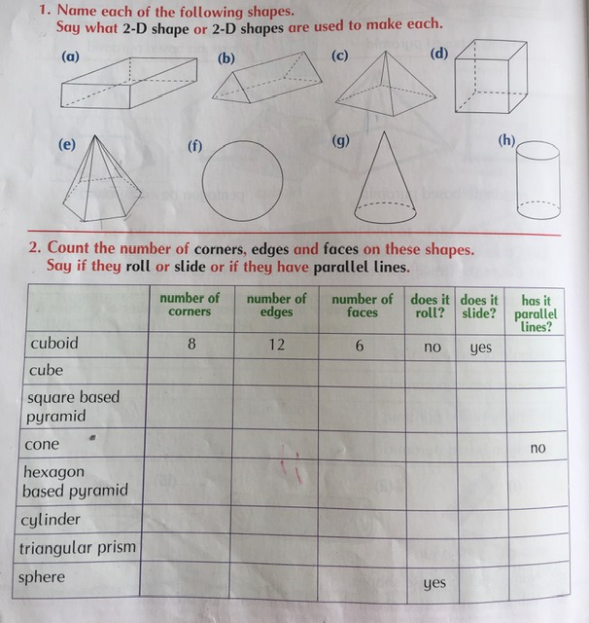

Thursday
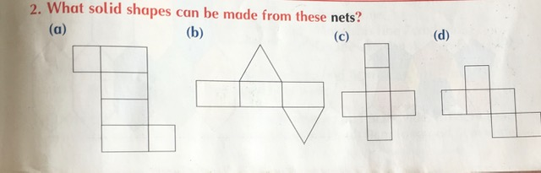

Friday
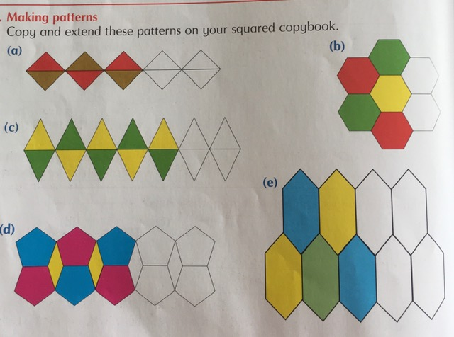

Well done on completing another week. Stay safe!!

