Topic : Measures

Length and perimeter
Language used in this Topic
Length width perimeter mm cm m km height estimate distance

Helpful Hints
Estimating lengths at home
How many stairs would you need to climb to climb 1 metre?
What is the longest room in the house?
Are the ceilings in all the rooms the same height?
Can you reach the highest shelf?
Who is the tallest/shortest person in the house?
Walk the perimeter of the room/ house/garden.

Conversion:

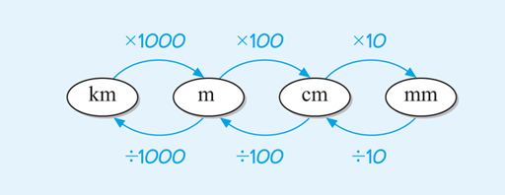

100cm = 1metre = 1.0m
50cm = ½ metre = 0.5m
25cm = ¼ metre = 0.25m
75cm = ¾ metre = 0.75m
10cm = 1/10 metre = 0.1m
20cm = 2/10 = 1/5 metre = 0.2m
Monday Q1 Tuesday Q2 Wednesday Q3 a,b,g,h,i
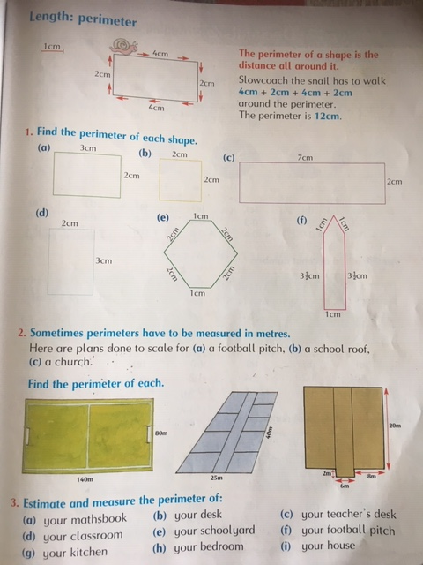

Thursday a-e Friday f-i
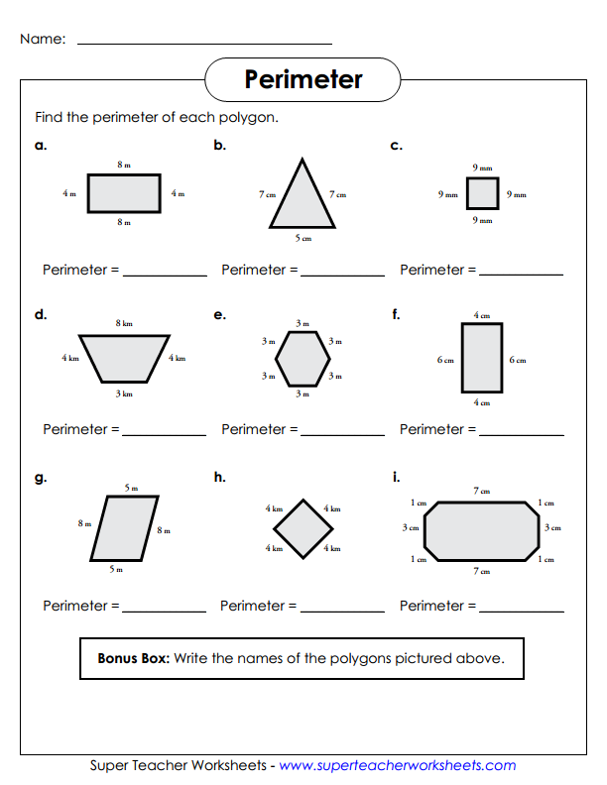Magic Work. Well done!!

