Hi everyone,
I hope that you are all keeping well. This week we are looking at Algebra and I have included some notes and examples to help you out. Try your best!!
Mrs. Doyle

Algebra – Rules & Properties

Language used in this Topic
"Operations" mean things like add, subtract, multiply, divide, squaring, etc. If it isn't a number it is probably an operation.

Priority of operation means to know when given a numerical equation containing different operations, such as addition, subtraction, multiplication, division, what operation you should carry out first.

BODMAS rule decides the order of operations for addition, subtraction, multiplication, division, etc. as shown below.

Topic Notes
Order of Operations –BODMAS

When you see something like...
7 + (6 × 5² + 3)
... what part should you calculate first? Start at the left and go to the right?
Or go from right to left? Calculate them in the wrong order, and you will get a wrong answer!
So, long ago people agreed to follow rules when doing calculations, and they are:
Do things in Brackets First. Example:
 |  | 6 × (5 + 3) | = | 6 × 8 | = | 48
 |  | 6 × (5 + 3) | = | 30 + 3 | = | 33 | (wrong)

Exponents (Powers, Roots) before Multiply, Divide, Add or Subtract. Example:
 |  | 5 × 2² | = | 5 × 4 | = | 20
 |  | 5 × 2² | = | 10² | = | 100 | (wrong)
Multiply or Divide before you Add or Subtract. Example:
 |  | 2 + 5 × 3 | = | 2 + 15 | = | 17
 |  | 2 + 5 × 3 | = | 7 × 3 | = | 21 | (wrong)
Otherwise just go left to right. Example:
 |  | 30 ÷ 5 × 3 | = | 6 × 3 | = | 18
 |  | 30 ÷ 5 × 3 | = | 30 ÷ 15 | = | 2 | (wrong)

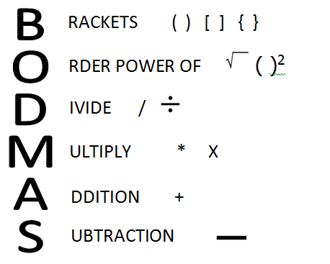
How Do I Remember It All? BODMAS !

B | Brackets first
O | Orders (ie Powers and Square Roots, etc.)
DM | Division and Multiplication (left-to-right)
AS | Addition and Subtraction (left-to-right)
Example 1: How do you work out 3 + 6 × 2 ?
Multiplication before Addition: First 6 × 2 = 12, then 3 + 12 = 15
Example 2: How do you work out (3 + 6) × 2 ?
Brackets first:First (3 + 6) = 9, then 9 × 2 = 18

Example 3: How do you work out 12 / 6 × 3 / 2 ?
Multiplication and Division rank equally, so just go left to right:
First 12 / 6 = 2, then 2 × 3 = 6, then 6 / 2 = 3

Patterns

Sequences - Finding a Rule - To find a missing number in a Sequence, first we must have a Rule.
A Sequence usually has a Rule, which is a way to find the value of each term.
Example: the sequence {3, 5, 7, 9, ...} starts at 3 and jumps 2 every time:
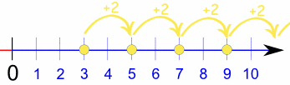

Infinite or Finite - When the sequence goes on forever it is called an infinite sequence, otherwise it is a finite sequence

Examples:
{1, 2, 3, 4, ...} is a very simple sequence (and it is an infinite sequence)
{20, 25, 30, 35, ...} is also an infinite sequence
{1, 3, 5, 7} is the sequence of the first 4 odd numbers (and is a finite sequence)
{4, 3, 2, 1} is 4 to 1 backwards
{1, 2, 4, 8, 16, 32, ...} is an infinite sequence where every term doubles
Square Numbers
1, 4, 9, 16, 25, 36, 49, 64, 81, ...
The next number is made by squaring where it is in the pattern.
Rule isx_{n} = n²
Cube Numbers
1, 8, 27, 64, 125, 216, 343, 512, 729, ...
The next number is made by cubing where it is in the pattern.
Rule isx_{n} = n³

Geometric Sequences are made by multiplying by the same value each time.
Example:
1, 3, 9, 27, 81, 243, ...
This sequence has a factor of 3 between each number.
The pattern is continued by multiplying by 3 each time.
Here is lots of patterns. Work through them over the week
Monday 1-5 Tuesday 6-10 Wednesday 11-15 Thursday 16-20 Friday 21-24
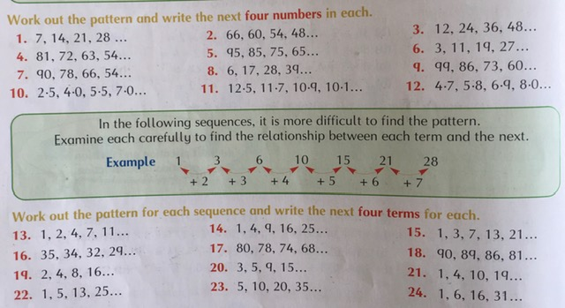

Well done on completing another week. Enjoy the weekend!!

