Hi everyone, I hope you are all keeping well and enjoying the sunny weather. This week we will do some revision of long multiplying and dividing, as well as fractions, decimals and percentages.
Refer to earlier notes to help you out and as always just do what you can!

Monday - Long multiplication
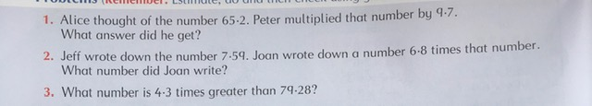
Tuesday – Long division
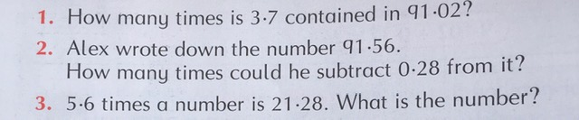
Wednesday – Fractions, Decimals and percentages
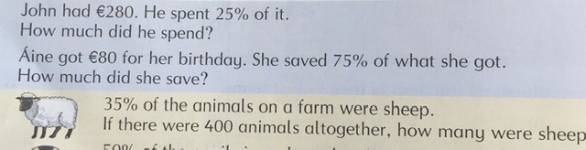
Thursday – Fractions, decimals and percentages
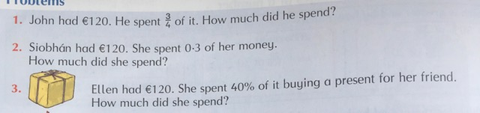

Friday – Fractions, decimals and percentages
