Maths: Further Challenge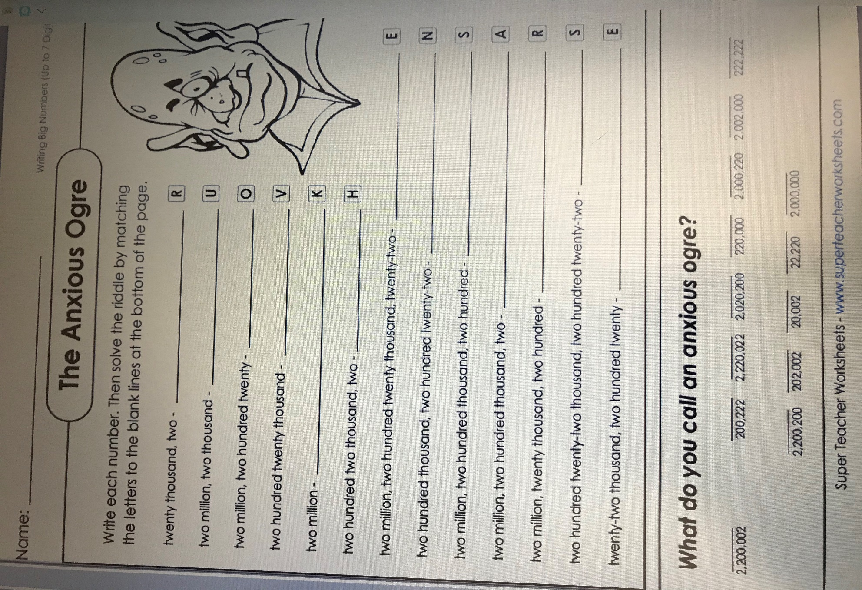
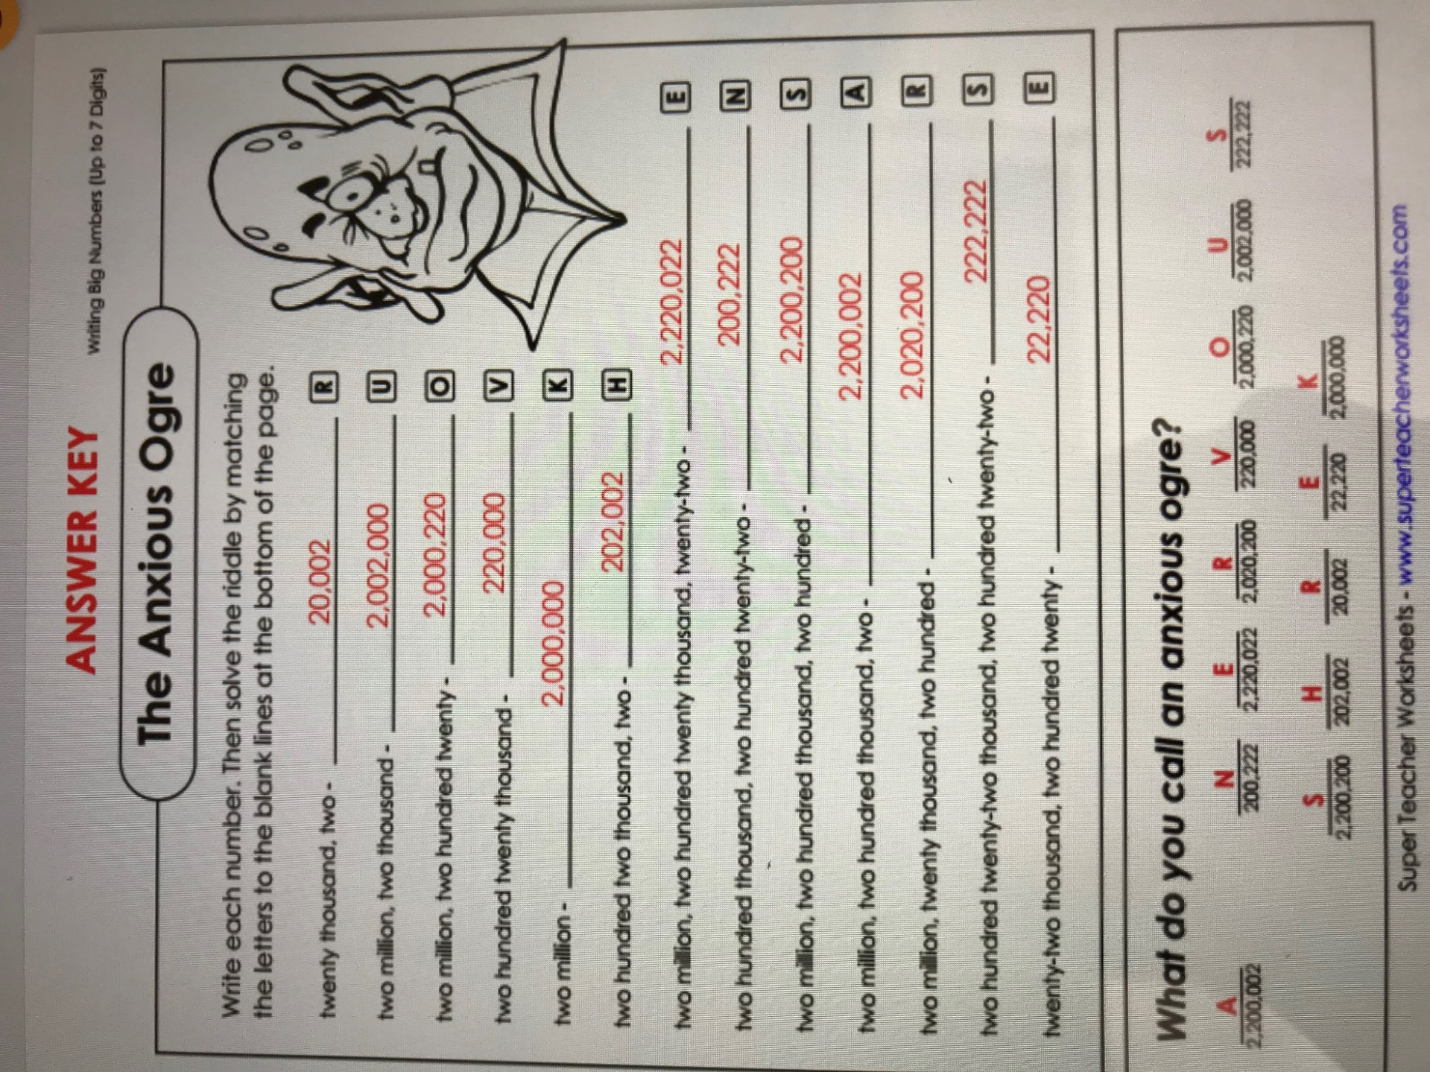

Lots of thinking involved in this one! I hope you enjoyed it. Stay safe,
Mrs. Hurson

