
Hello and I hope everyone had a nice Easter and enjoyed the good weather safely at home. As we are off again next week, I have set out some more schoolwork for you to continue with at home.
Note: As I have said in previous weeks complete work as best you can and do not worry if you get stuck in any area. Just skip on to the next thing and do your best in each topic area! That will be enough!
Ms. Lynch has created an excellent resource for the “We are Writers” whole schoolbook. I have the resources she created at the end of this document and the draft version of your chosen writing could be worked on this week. The information is set out in the information she had included.
There is also an art lesson and a music lesson after the Friday lesson.
In relation to PE, Ms Healy has put together an active schools’ whole school PE programme which can be found on the Active School Flag section of our website.
As I have previously mention RTE have 10@10 exercise routines available which you can complete at home. The link is below for anyone who hasn’t used it yet.
https://rtejr.rte.ie/10at10/
Also, with the permission of a parent/guardian you could use some of the exercise activities that fitness coach Joe Wicks has made available on YouTube for children.
Extra Activities are not compulsory, but you may find them helpful for understanding new subject areas and I suggest checking them out as you go along.
Look after yourselves,
Mr Hayden.

Monday
Maths: This week, we are looking at Algebra 2 which deals with extending and using patterns of numbers. We will also look at patterns to understand what a missing number is.
For example, in this pattern 10, 20, 30, ?, 50, 60, 70. The missing number is 40 as we can see that the pattern is jumping in 10’s.
Check this video out to learn about skip counting in 5’s and 10’s which helps with our understanding of finding missing numbers in number patterns of skips in 2’s, 5’s and 10’s.
https://www.youtube.com/watch?v=wcxaDBbOR5U
Practice skip counting in 2’s, 5’s and 10’s. Write the patterns down to help you.
Now try these:
2, 4, 6, 8, 10, 12, ?, 16, 18, 20. What is missing in the space with the”?”.
5, 10, 15, 20, ?, 30, 35, 40. What is missing in the space with the”?”.
10, 20, ?, 40, 50, 60, 70, 80, ?, 100. What is missing in the space with the”?”.
If you can answer the above questions, then you are ready to answer today’s questions below in your copy.
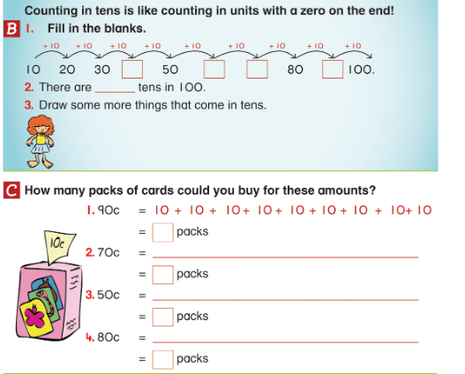
English:
Spellings: This week there will be 15 spellings only. You can learn them over the week and maybe get someone to test you at the end of the week. Use the same method as we normally use in class.
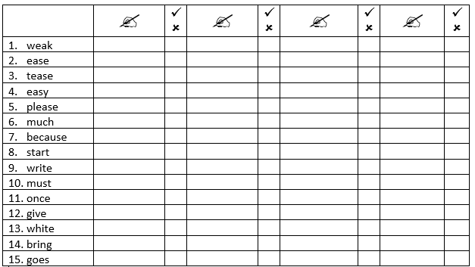
We will continue to read the story ‘An Amazing Dog’. Read one page a day from Monday to Friday.
Vocabulary: Ask about the meaning of any words you don’t understand.
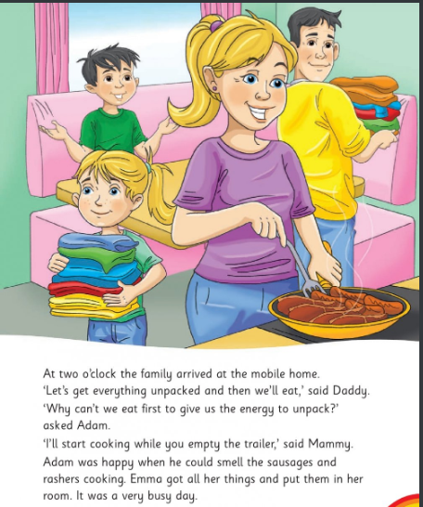

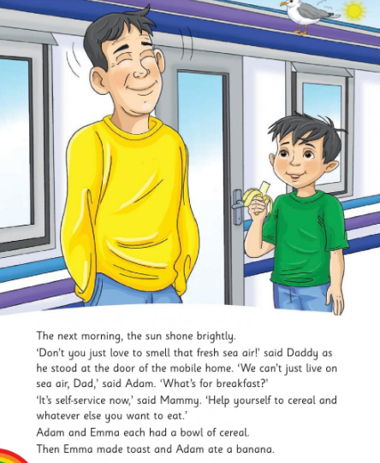

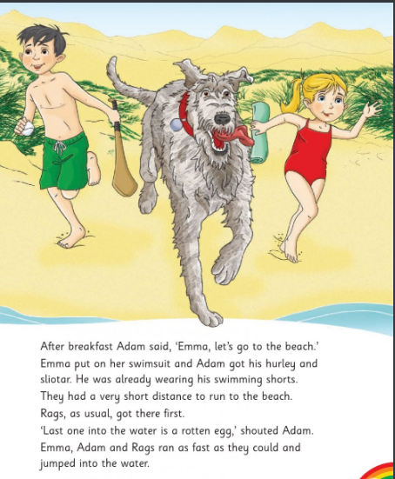
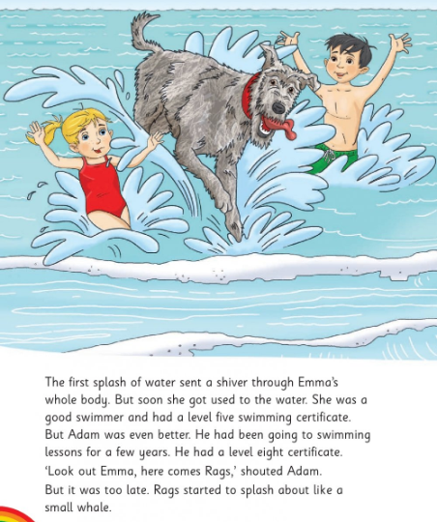
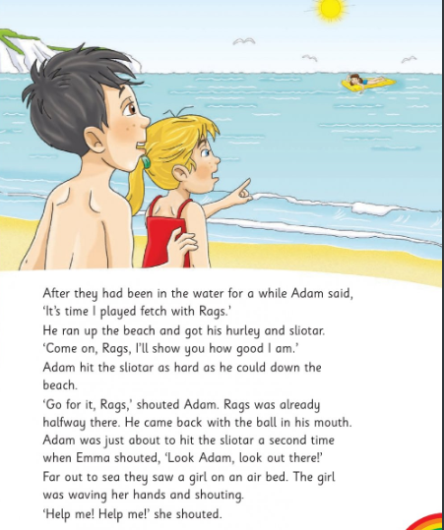
Adding “ing” to the end of words.
By adding “ing” we can change how we use the words below. For example, the word “turn” can be changed to “turning” and used in a different way.
“Turn the car”. By adding “ing” we use the word “turn” in a new way. “She is turning the car.”

Complete the below exercise in your copies.
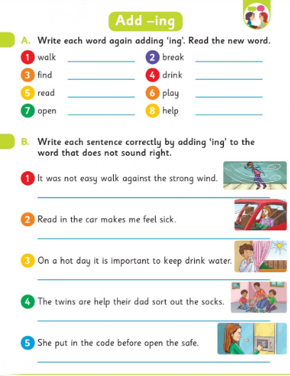

Irish: Revision. Write the sentences correctly. Remember the hint about the capital letters.
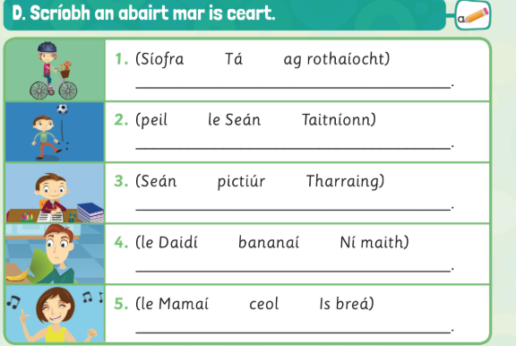

SESE – Geography – Re-read for revision the chapter below on cardinal direction from last week and complete activity C in your copybook.
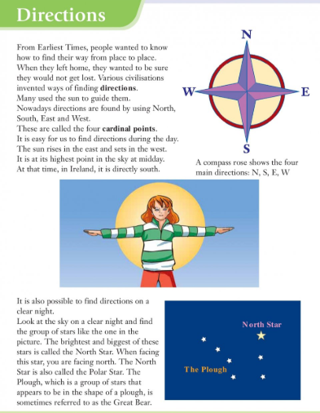
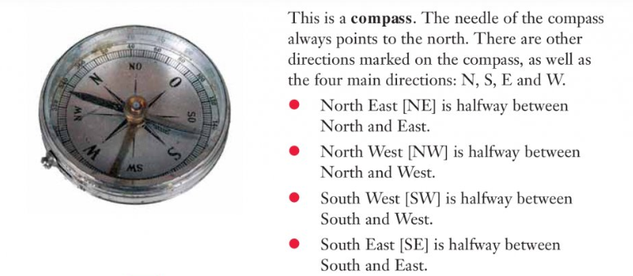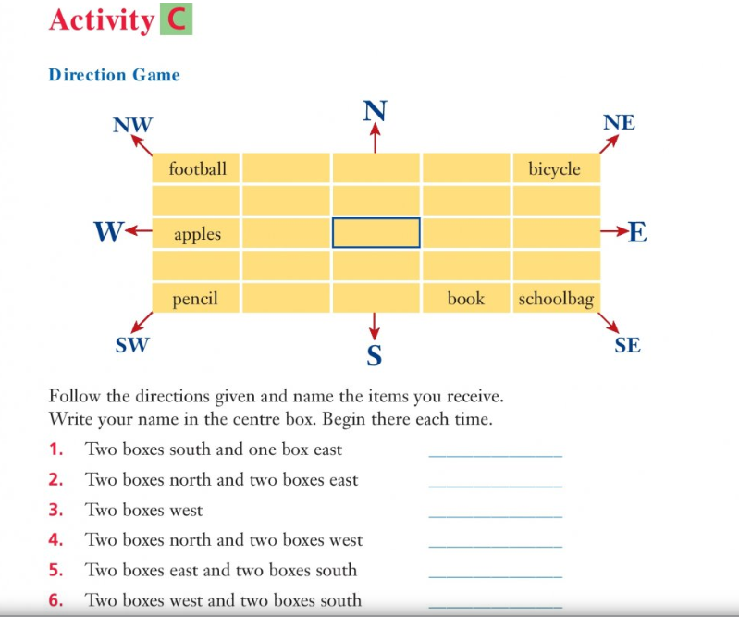

P.E.
Go to Active School Flag section of our website to find todays activity.
- RTE 10@10 https://rtejr.rte.ie/10at10/
- Joe Wicks fitness coach videos are also available on YouTube once you have the permission of an adult.

Monday Completed!
Well Done!!

Tuesday
Maths: Algebra 2 continued.
Look back over the video and questions from yesterday’s class.
Think of money and how it is has different patterns of counting (coins).
10c coins - so ten 10c coins make up 100c (which is €1)
5c coins – so five 5c coins make up 25c.
2c coins – so twenty 2c coins make up 40c.
For example, if we have seven 10c coins in our hand we can skip count in 10’s to see how much we have – 70c.

Try to think of other examples where we can use skip counting to count items quickly in a fixed pattern.
Then try todays questions.
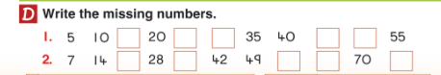

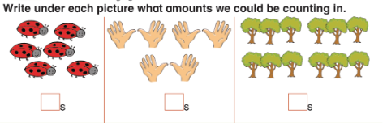
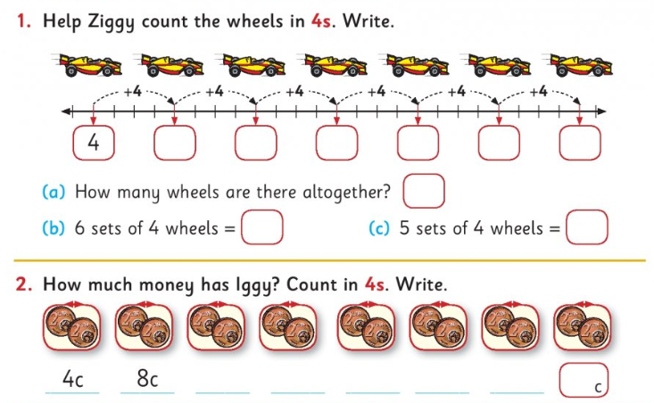

Irish
Revision. Líon na bearnaí.
Complete the sentences beside each picture.
Write the full sentences in copy. Make up your own place for the last picture.
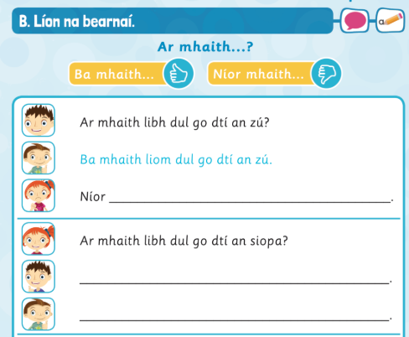
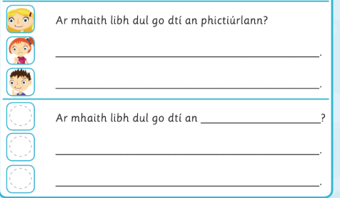

English
Read the next page in the
Read the following story “The Ugly Duckling” and answer the question that follow.
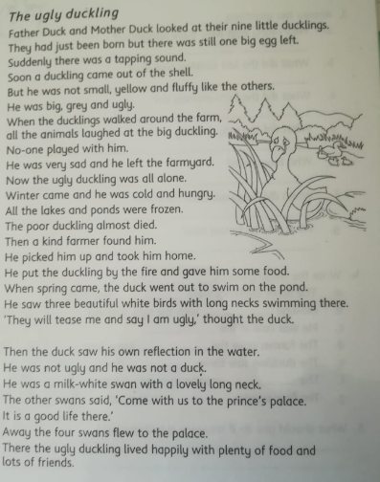
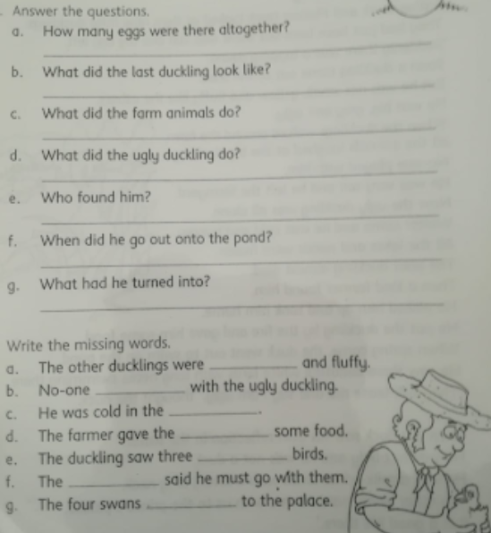

SESE - Geography
Re-read the chapter Directions. At this stage from studying this chapter before Easter, yesterday and today, you should be able too describe the cardinal point on a map or compass!
You should now have the knowledge to be able to complete activity D below.

Extra activity:
Talk to someone at home and talk to them about where your house is situated using the cardinal directions when compared to:
- Dublin
- Galway – (you can use the map from the Geography lesson from before Easter.)
- Your school
- Drogheda
- Dundalk

P.E.
Go to Active School Flag section of our website to find todays activity.
- RTE 10@10
https://rtejr.rte.ie/10at10/
- Joe Wicks fitness coach videos are also available on YouTube once you have the permission of an adult.

Tuesday Completed!
Well Done!!

Wednesday
Maths: Algebra 2 continued
Today in continuing our look at patterns and counting up in a certain number pattern such as 2’s, 5’s, 8’s we are going to look at 100 squares and practice starting at a number we are given and jumping /skipping upwards in a given certain number jump/skip.
Take your time and if you can’t print the questions just write down the first few answers if you can colour them in. Think and plan before you start. Good luck!
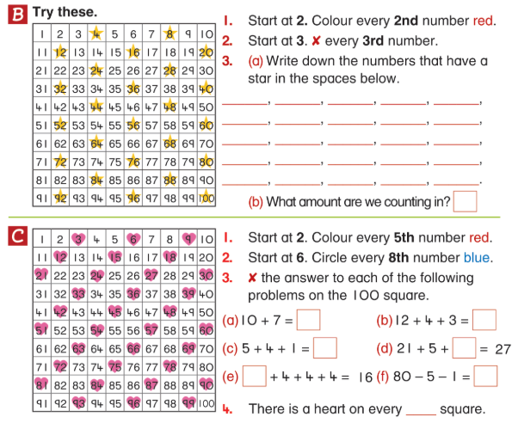

Irish
Revision. Ar chuala tú….? – Did you hear?
Write the answer in your copy with the choices below.
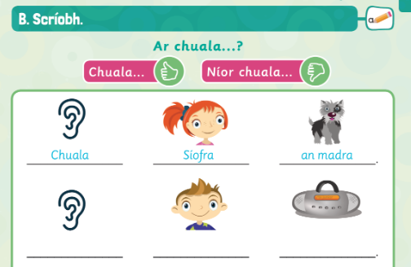
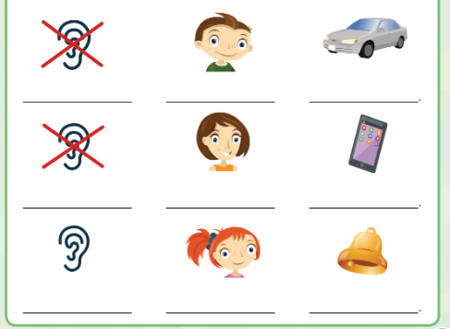
Cloigín = bell
Fón póca = mobile (pocket) phone

English
Read next page of the story “An Amazing Dog”.

Read the story below, “The Witch’s Cat” which is in the Starways Skills Book (pg. 17) I gave out on 12th March. Write the story out in your copy and fill in the missing words in the story. Make sure you understand all the words that are in blue before you start.
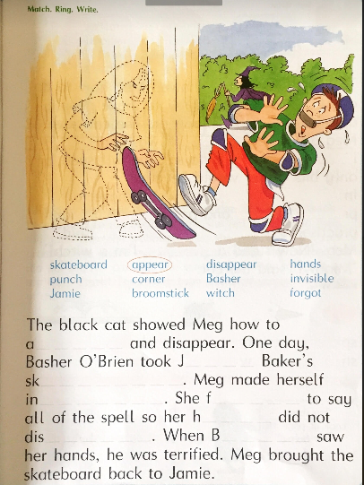

SESE – History
Read the chapter “The Vikings in Ireland” (it may be broken up into two days of reading) and attempt Activity A when you have finished reading the story.

“The Vikings in Ireland”
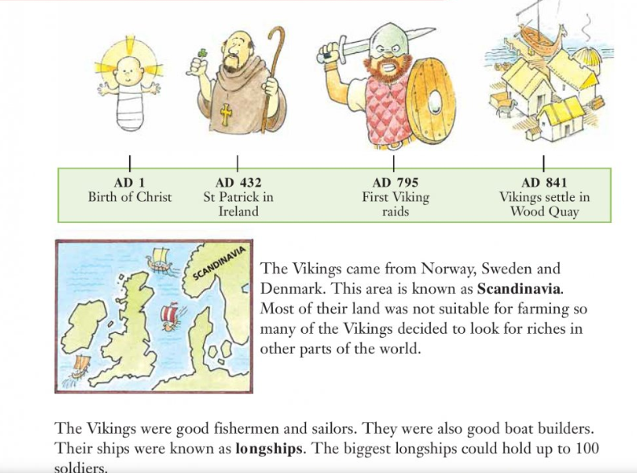
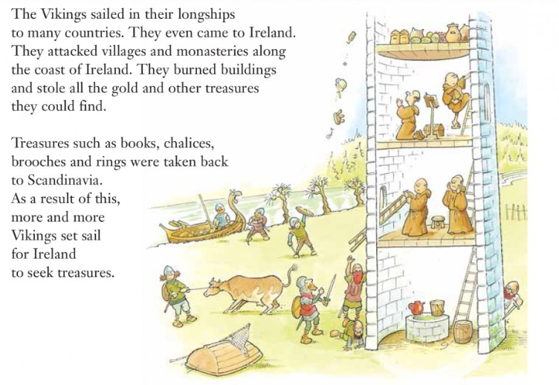
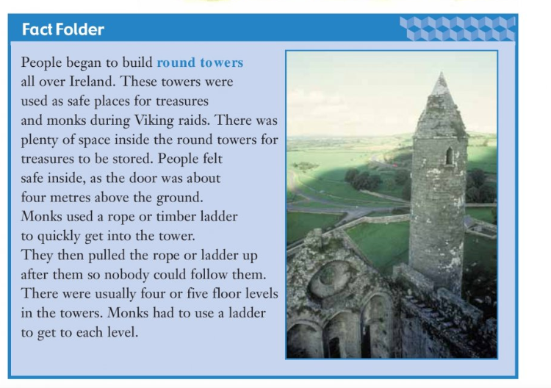
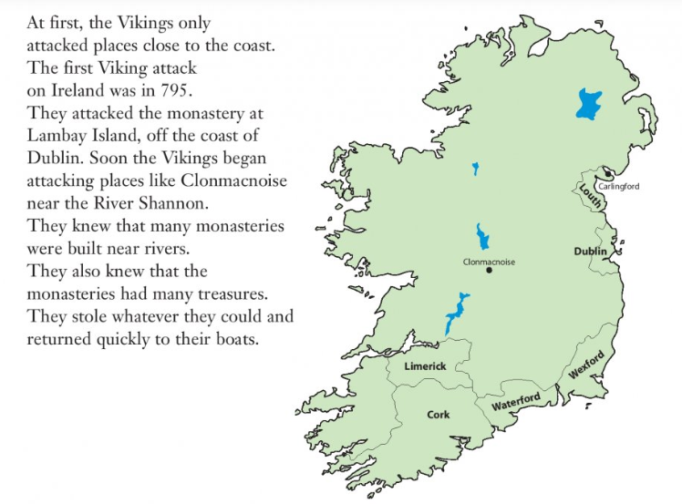
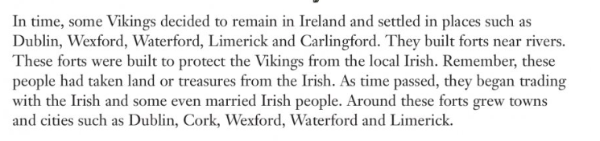
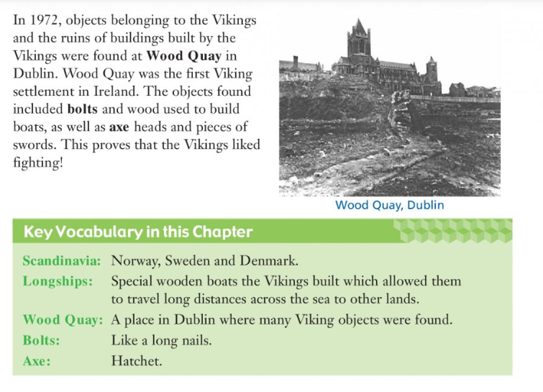
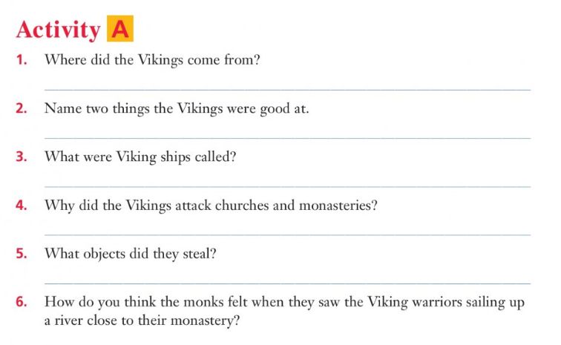

P.E.
Go to Active School Flag section of our website to find todays activity.
- RTE 10@10 https://rtejr.rte.ie/10at10/
- Joe Wicks fitness coach videos are also available on YouTube once you have the permission of an adult.

Wednesday Completed!
Well Done!!

Thursday
Maths Algebra 2 continued……
At this stage you should be able to number jump/skip in 2’s, 5’s, 8’s and 10’s. If not, it is important not to worry and to keep practicing (only spend a little while – not all day!) as practice makes perfect.
Try this activity (use different colours in your copy for skipping when doing (a), (b), (c) and (d).

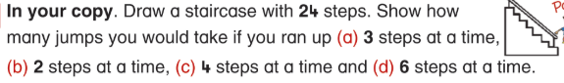

Use your knowledge of skipping/jumping in 4’s to answer the following questions (write down your 4’s skipping pattern in your copy to help you if you need to).
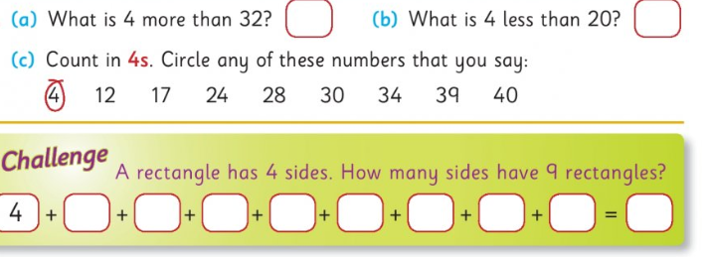
Use your knowledge of jumping in 5’s to answer the questions below.

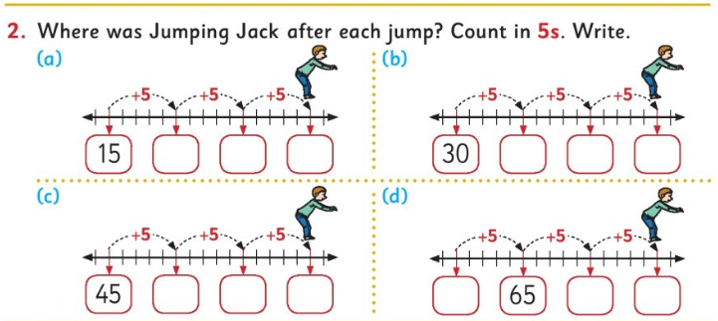

Irish
Revision. Write the sentences correctly.
Complete questions 1-4 in copy.
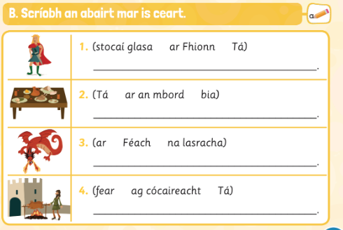
Lasracha = flames

English
Read next page of the story “An Amazing Dog”.

Complete the following grammar work in your copy book. It is about exclamation marks or “!”.
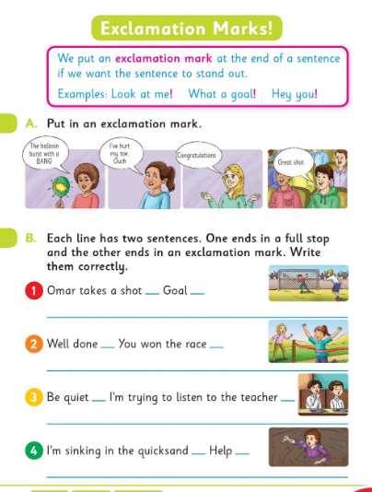

SESE - History
Re-read or finish reading “The Vikings in Ireland” and complete Activity B

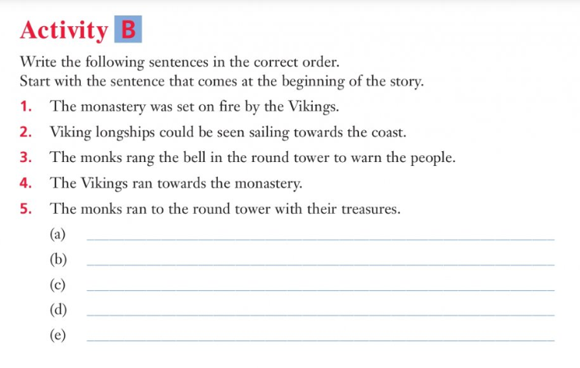
Extra Activity – True or False
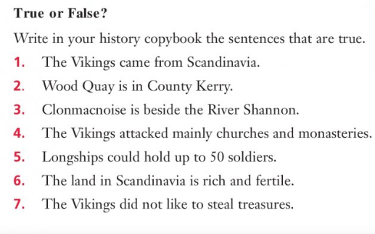

P.E.
Go to Active School Flag section of our website to find todays activity.
- RTE 10@10 https://rtejr.rte.ie/10at10/
- Joe Wicks fitness coach videos are also available on YouTube once you have the permission of an adult

Thursday Completed!
Well Done!!

Friday
Maths Algebra – check up!
Now we can do a check up on our learning to see what we have learned during the week.
Answer the questions below:
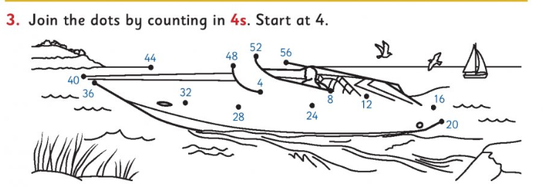

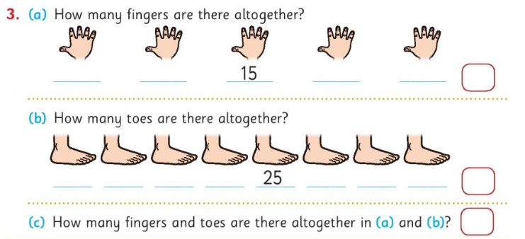

Question - Draw 10 dots on each butterfly. Count in 10’s. Write.
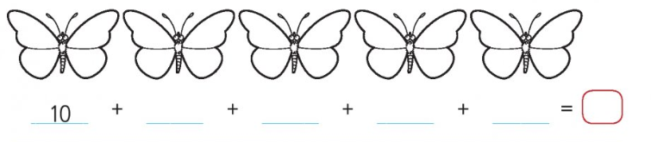

Question
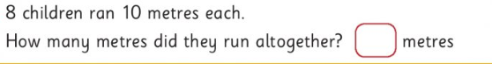

Irish
Revision – Fíor nó bréagach = true or false
Write the sentences in your copy and answer if they are “fíor nó bréagach”.

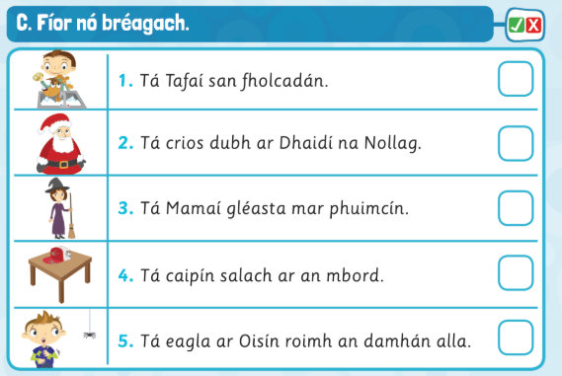

English
Spelling test – get someone at home to do your spelling test with you!

Read final page of the story for this week, “An Amazing Dog”.
Then answer the questions below on the story we have read so far. Remember, capitals letters in correct places, neat writing and full sentences.

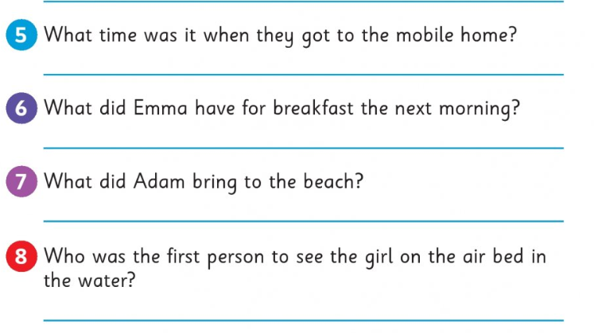

Poetry – practice reading aloud the following poem. Remember “practice” means reading the poem more than once.
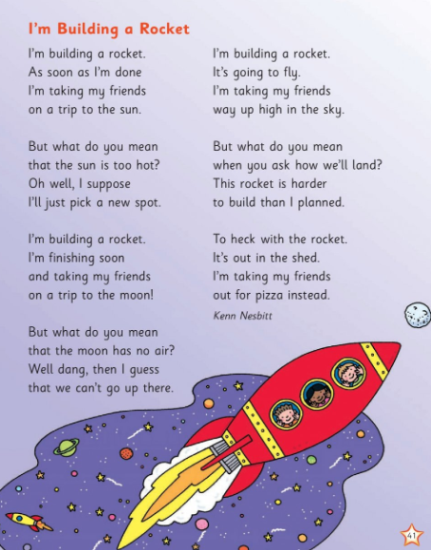

SESE – Science – Materials
Materials – Liquids and Solids
For the purposes of this chapter –
A liquid – flows easily and its shape depends on the container it is poured or held in (example water poured in a bottle or cup).
A solid – doesn’t flow and mostly keeps its shape and doesn’t depend on the container it is held in ( a brick in a box or a bag will still keep the same shape).

To investigate how some solids dissolve in water.
Experiment time!! – MAKE SURE THAT A PARENT/GUARDIAN IS WITH YOU WHEN YOU CARRY OUT ANY EXPERIMENT.
The objective of this experiment is to explore how some solids dissolve in liquids while other do not. Hopefully you should have what you need for this already at home although at the current time it may be difficult to get some sand but you may still attempt the experiment with other solids from the kitchen and fill in your results. Don’t worry if you don’t, you can always do it another time when you have what you need! Good luck!!
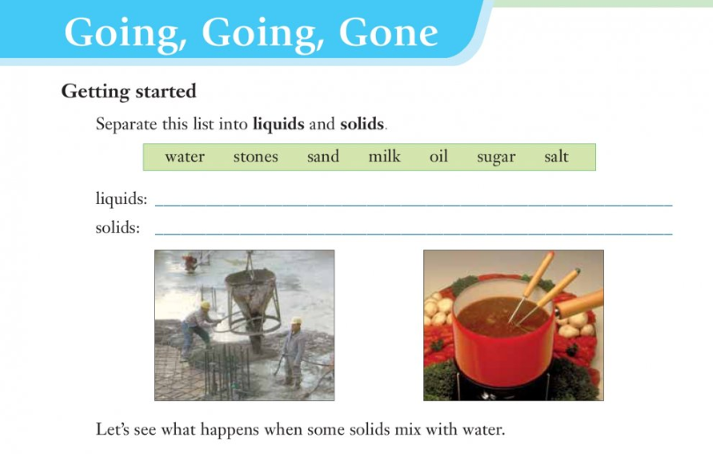
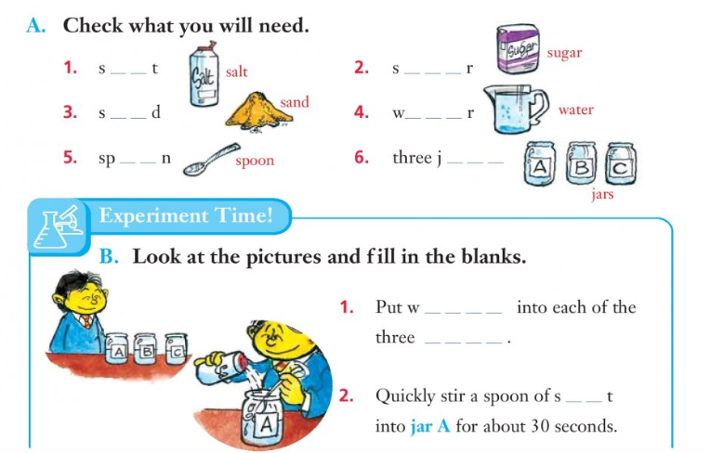

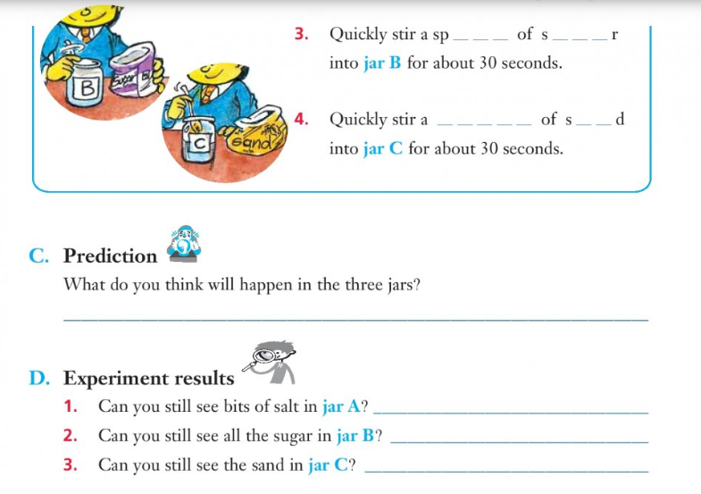
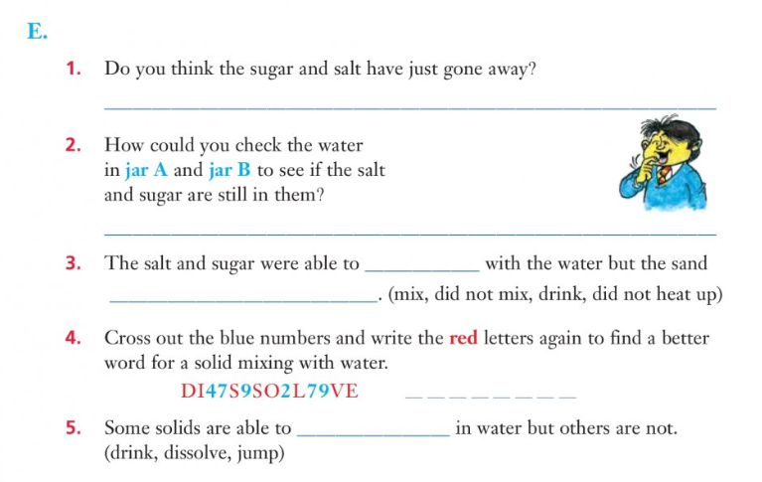

Extra Activity.
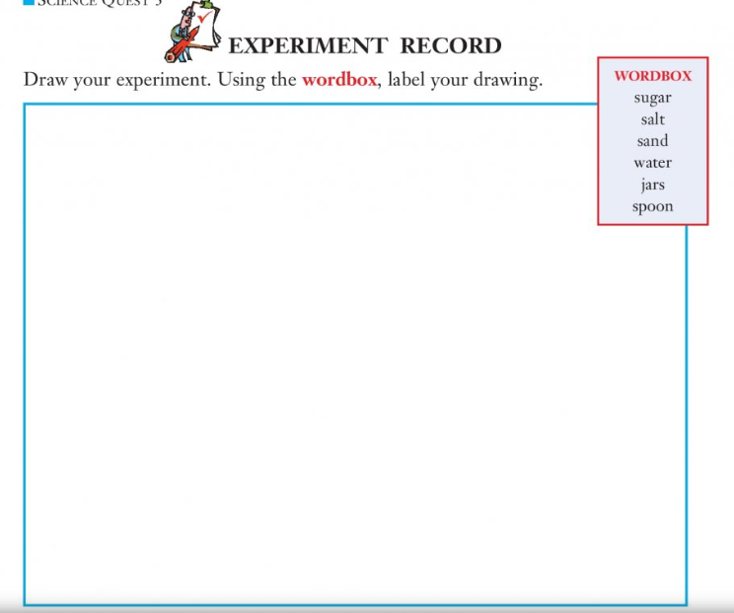
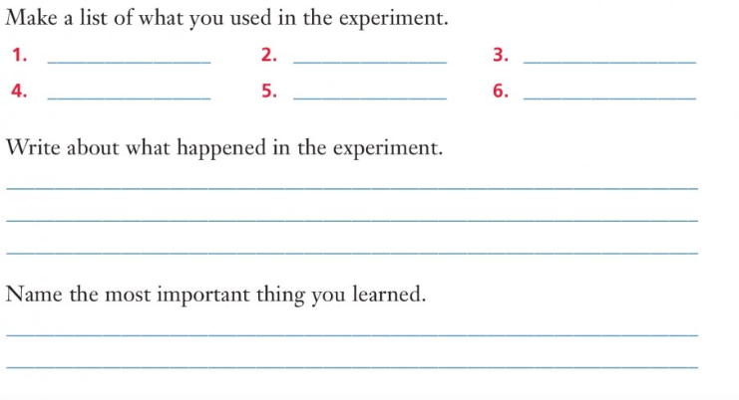

P.E.
Go to Active School Flag section of our website to find todays activity.
- RTE 10@10 https://rtejr.rte.ie/10at10/
- Joe Wicks fitness coach videos are also available on YouTube once you have the permission of an adult.

Friday Completed!
Well Done!!


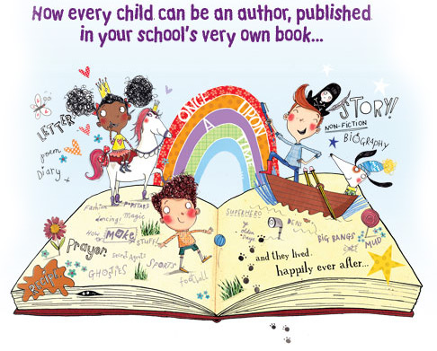
2nd Class ‘We are Writers’ Support Resources
This week for your child’s creative writing they can work on their piece of writing for the ‘We are Writers’ whole school book. Each pupil will have a piece of writing in this book. This book will be a record of this time that will go down in history and we hope to publish it in due course. We encourage adult help at home with this. It is up to you how you help your child comprehend this time, but here are some ideas to help you. We appreciate that younger children may not understand what is going on and that’s okay. For them their world right now is staying at home and hopefully making the most of the good weather and what they have at home. You can help your child write a poem, a prayer, a diary entry, a recount of a memorable day over this period or maybe you might like to do an interview over the phone with a grandparent. We hope you will enjoy this exercise and it will give an opportunity for you to chat with your child and help them process the situation and ease any anxiety.
Please do not stress or worry about this exercise. At your earliest convenience please email it directly to: wearewritersns@gmaill.com
It does not have to be in any particular format, please just ensure you include your child’s name and class. Looking forward to reading your piece.

Poem
We have already received a fantastic poem, ‘Staying at Home’, from Edie in 1st Class. Well done Edie! Edie’s poem acknowledged that while we must stay at home how lucky we are to have the countryside around us and our health to work and play. You could find some inspiration from this and write about what you’re grateful for. Your poem doesn’t have to rhyme and can be in whatever format you choose.
This time may have given you more time for walks and play in your garden and the opportunity to stop and appreciate the beauty in the natural world around us. You could write a senses poem in which you describe what you can see, hear, feel, smell and taste. When you give all this detail, it brings your writing to life! And gives the reader a clear image of what you’re referring to. This can be enhanced more by using good adjectives.
https://youtu.be/5ZkMbLkGims - adjectives explained
https://youtu.be/hifcUYaACzI - adjectives explained
You could also use some similes in your poem. Similes make a comparison between two things using the words like or as. Here are some examples of similes:
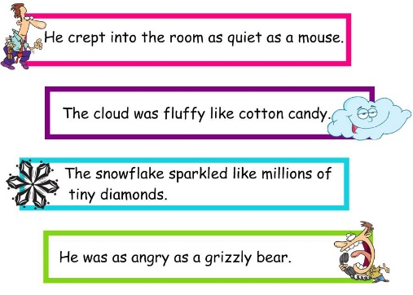
https://youtu.be/Ip7o5jKZQME - How to write a five senses poem with similes.
https://youtu.be/pm6zt24w0qU - Explanation of similes

Prayer
You may decide to write a prayer instead. Below is a lovely video link that can help you remember who you can pray for.
https://youtu.be/IihBCl_A4x4 - The Five Finger Prayer
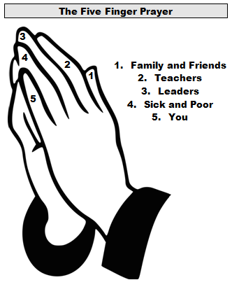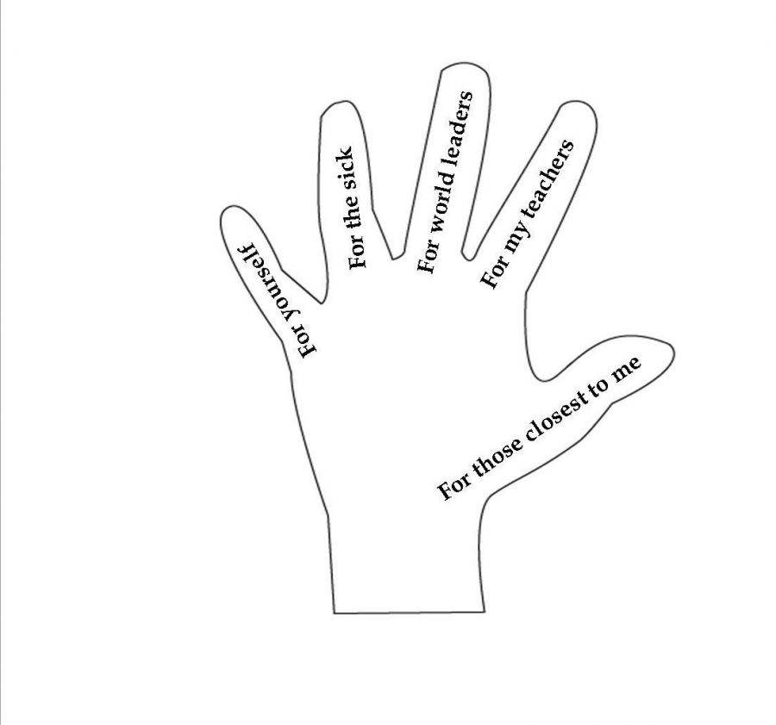

Diary Entry
In a diary entry your child can recall what you did that day and how they feel about missing school and not being able to visit grandparents, cousins and friends and what they’re looking forward to after this. Maybe fill us in on the fun activities they’re doing at home. Diary entries are written in a friendly style and the writer can express how they’re feeling about everything that’s going on in their life at the moment.
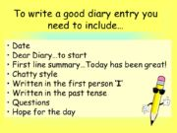

Recount
Recall an unforgettable or extraordinary day. Here are some tips to help you write a recount.
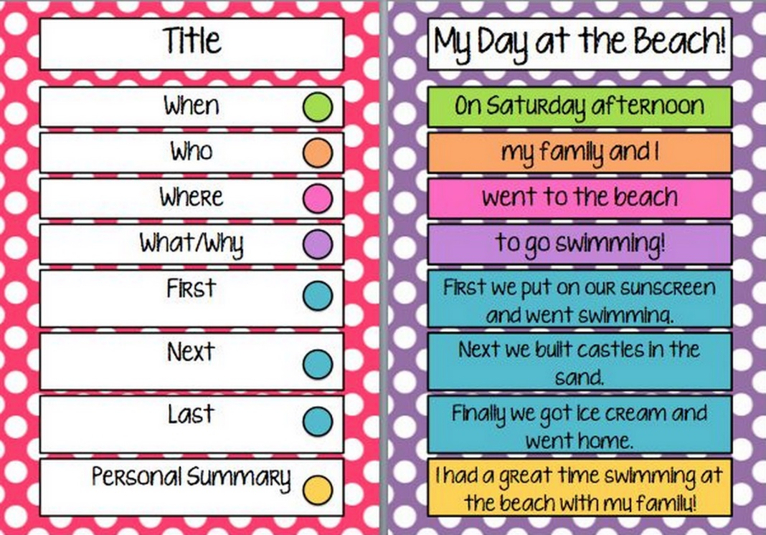

Interview with Grandparent
An interview with a grandparent could be fun to do! Here are some sample questions below you can choose from, 10 questions is plenty! Of course, feel free to make up some of your own questions.
Questions for Grandparents
- How are you doing? What were you up to today?
- Are you staying at home every day? What do you find the hardest about this pandemic? What are you enjoying?
- How do you feel about the current situation? Have you ever experienced anything like this before in your lifetime?
- What are you thankful for?
- What makes you happy? What do you think is important in life?
- What is your hope for your children and grandchildren?
- What do you enjoy most about being a grandparent?
- What is different about growing up today than when you were a child?

- Were you named after a family member or does your name have a special meaning?
- Do you have a nickname that your siblings or friends call you? How did you get the nickname?
- Where were you born? What was your house like as a child?
- Where have you lived? Tell me about your first house.
- Where have you travelled? What is your favourite place to visit?
- Do you have a favourite family holiday memory?
- How did your family spend time together when you were young?
- Have you owned any pets? What was your first pet?
- What is the most important lesson that your parents taught you?
- What did your friends do for fun when you were young? Did you have a best friend?
- Did you have a favourite toy as a child?
- Did you ever get in trouble as a child?
- Did you enjoy school when you were younger?
- How did you meet grandma/grandpa? Tell me your story.
- Did you have a job? What was your first job?
- What did you want to be when you grew up?
- What was your first car?
- Do you practice a religion? What impact has religion had on your life?
- Who are your children? What is your favourite memory with your children?
- How do you handle stress?
- What could you tell me that I would be surprised to learn about you?
- What were your grandparents like?
- What is the earliest memory that you have?
- Tell me about the day when my mom/dad was born?

Remember, all of the above are just some suggestions to help you. When you are happy with your child’s piece of work email it to wearewriterssnc@gmail.com
It does not have to be in any particular format. Please ensure you note your child’s full name and class is also included in the email. We look forward to receiving your piece.

Hope you are all keeping safe and well,
Ms Lynch

Music
We mostly use musical instruments such as pianos, guitars, drums, and tin whistles to make music. But you probably know that we don’t always need to have or be able to play musical instruments to make music or sound. We have voices to sing and we can use our mouth to whistle a song too.
You also probably know that we can use our bodies to make music. This is called body percussion where we use parts of our bodies to make sounds and musical beats. The most obvious is our use of hands to clap a beat. But we can also use our knees, thighs and chest/stomach to “drum” or clap a beat or piece of music by using them with our hands.
For this week’s music lesson, I have included two video clips from the BBC children’s channel which have music and dance pieces you can learn using body percussion and movement/dance. Have a go at the videos that are here and as you know there are plenty more body percussion videos you could check out on YouTube with the permission of a parent/guardian and practice them. See if you can create a body percussion beat to your favourite song! Have fun!
https://www.youtube.com/watch?v=sW2DY1OpgrI
https://www.youtube.com/watch?v=QOh1P1ZcTaU

Art –
For this lesson, linking to our theme in History of the Viking in Ireland, I would like you to create a drawing which you can colour or paint of Viking helmet, shield or longboat/longboat.

As we learned in our history this week, the Vikings used their longboats to explore and attack places and they arrived in Ireland and over time some decided to stay in Ireland. They must have looked very fierce when they first attacked Ireland with their big longboats and their helmets and shields which made them look very fierce and frightening.
I have included some pictures of what the Vikings may have looked like which you can print off and colour if you have access to a printer and wished to complete.
I have also included examples of Viking helmets, shields, and longboats which you do not have to print as you can design your own.

Enjoy creating your art which ever one you decide to pick.
