Day 1  Irish  Answers | Q1 | Tá Seán agus Síofra ar an tolg.
Day 1  Irish  Answers | Q2 | Tá Oisín ag súgradh leis an traein.
Day 1  Irish  Answers | Q3
Day 1  Irish  Answers | Q4
Day 1  Irish  Answers | Q5
Day 1  Maths  Answers | Q1 | 3D Shape hunt around your home. Ask an adult to check your work. Here are some examples:
Day 1  Maths  Answers | Q2 | Cuboid: cereal box, toothpaste box , block, speaker
Day 1  Maths  Answers | Q3 | Cylinder: Tin of beans, peas, spray oil, toilet rolls, kitchen paper rolls
Day 1  Maths  Answers | Q4 | Cone: party hat, ice- cream cone, top of pencil
Day 1  Maths  Answers | Q5
Day 1  English  Answers | Q1 | Phonics ‘ea’ – You may have found any of the following: peas, please, sea, eat, fleas, plea.
Day 1  English  Answers | Q2 | Check that your ‘silly sentence’has capital letter at start and full stop at end.
Day 1  Science  Answers | Q1 | Forces: Push and pull – ask adult to check your work.
Day 1  Science  Answers |  | Here are some examples of things you might have found-
Day 1  Science  Answers |  | Push : box, chair, door, toy, pram, button, wheel barrow
Day 1  Science  Answers |  | Pull: toy on a string or lead, pull a door open, laces, a trailer

Day 2  Irish  Answers | Q1 | Answers on online game
Day 2  Irish  Answers | Q2
Day 2  Irish  Answers | Q3
Day 2  Irish  Answers | Q4
Day 2  Irish  Answers | Q5
Day 2  Maths  Answers | Q1 | 3D shape hunt around your home- ask adult to check answers
Day 2  Maths  Answers |  | Here are some examples of objects you may have found:
Day 2  Maths  Answers |  | Cube: dice, box ( with all square faces), oxo cube, rubix cube, block, sugar cube
Day 2  Maths  Answers |  | Sphere: ball, globe, orange, apple, balloon, marbles
Day 2  English  Answers | Q1 | Wordsearch- there were 12 words to find in total.
Day 2  English  Answers | Q2
Day 2  English  Answers | Q3
Day 2  English  Answers | Q4
Day 2  English  Answers | Q5
Day 2  Geog  Answers | Q1 | Sources of water in the locality- you may have found some of the following:
Day 2  Geog  Answers | Q2 | The Glyde River/ River Dee/ River Boyne
Day 2  Geog  Answers | Q3 | The Irish Sea ( at Port Beach/ Dunany/ Annagassan/ Salterstown/ Clogherhead/Carlingford/ Blackrock…………)
Day 2  Geog  Answers | Q4 | Rathescar Lake
Day 2  Geog  Answers | Q5 | You may have found more. Well done!

Day 3  Irish  Answers | Q1 | Answers on online game
Day 3  Irish  Answers | Q2
Day 3  Irish  Answers | Q3
Day 3  Irish  Answers | Q4
Day 3  Irish  Answers | Q5
Day 3  Maths  Answers | Q1 | 3D Shape picture challenge Cuboids= I found 6!
Day 3  Maths  Answers | Q2 | Cones= I found 5
Day 3  Maths  Answers | Q3 | Spheres = I found 4
Day 3  Maths  Answers | Q4 | Cylinders = I found 7
Day 3  Maths  Answers | Q5 | Cubes =2
Day 3  English  Answers | Q1 | There were ten eggs altogether.
Day 3  English  Answers | Q2 | The last duckling was big, grey and ugly.
Day 3  English  Answers | Q3 | The ugly duckling left the farmyard.
Day 3  English  Answers | Q4 | When spring came the duckling went out to swim in the pond.
Day 3  English  Answers | Q5 | Example: I think the ugly duckling was very surprised and shocked to see his reflection in the pond. I think this because his appearance had completely changed.
Day 3  History  Answers | Q1 | I hope you enjoyed the story of the Children of Lir. Ask an adult to check that your pictures match the sentences. Well Done!

Day 4  Irish  Answers | Q1 | Answers online .
Day 4  Irish  Answers | Q2 | Can you sing the song/rap by yourself ?
Day 4  Maths  Answers | Q1 | 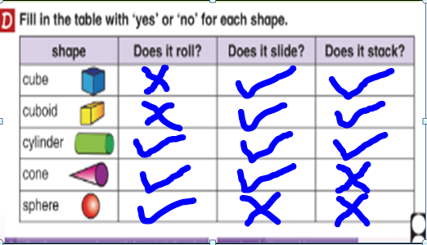
Day 4  English  Answers | Q1 | We are Writers task - ongoing
Day 4  English  Answers | Q2
Day 4  English  Answers | Q3
Day 4  English  Answers | Q4
Day 4  English  Answers | Q5
Day 4  Music  Answers | Q1 | Listening and responding- Instruments ( You may have heard many orchestral instruments. For example- piano, flute,clarinet, violin.  But the double bass had a big role in this piece.
Day 4  Music  Answers | Q2 | Picture

Day 5  Irish  Answers | Q1 | Comhrá – Could you read the comhrá by yourself or with the help of the online version?
Day 5  Maths  Answers | Q1 | 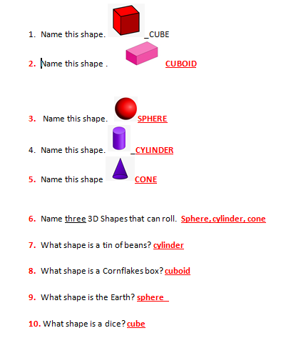
Day 5  English  Answers | Q1 | Spelling Test .  How did you do?  Are there any spellings that were very tricky?  Try to write them out again next week to have more practise with them.  Great job! You are amazing as always!
Day 5  Art  Answers | Q1
Day 5  Art  Answers | Q2
Day 5  Art  Answers | Q3
Day 5  Art  Answers | Q4
Day 5  Art  Answers | Q5

