Dear 6th Class,
I hope you are keeping well! Unfortunately we cannot return to school just yet, so I have outlined below another week of work for you to complete at home.
Hopefully you got on well with the work I set for you before the Easter holidays and found the corrections easy to follow.
At the end of the week the corrections will be uploaded. It is important for you to go through these and to learn from any mistakes you may have made.
I know these are different times, and completing work at home is very different to completing a normal school week. If you are finding the work difficult, work with someone at home and decide on a workload that you are capable of completing.
I suggest trying to stick to a timetable as much as possible. Below is a sample timetable you may want to use.
Monday | Tuesday | Wednesday | Thursday | Friday
Maths | Maths | Maths | Maths | Maths
Irish | Irish | Irish | Irish | Irish
English | English | English | English | English
History | Geography | Science | Music | Art
PE | PE | PE | PE | PE

Sticking to a timetable will help you to plan out your day and also balance the work out for the week. This will ensure you are not left with a lot of work to do at the end of the week.
I can’t stress enough how important it is for you to keep engaging with the work I am setting you. It is also so important for you to keep reading while at home. Even if you do not have any new books, re-reading old books is also very beneficial for you.
In relation to PE, Ms Healy has put together an active schools whole school PE programme which can be found on the Active School Flag section of our website.
Joe Wicks (The Body Coach TV) YouTube channel is also very good for exercise videos. https://www.youtube.com/channel/UCAxW1XT0iEJo0TYlRfn6rYQ
I really hope to see you all soon,
Missing you all,
Mr Carroll.

Monday:
Maths:
I hope you got on okay with the percentages last week. We are going to continue with the percentages chapter this week.
Below is the same link to a YouTube video on how to find the percentage profit and the percentage loss of an item. Watch this video again to refresh your memory.
https://www.youtube.com/watch?v=FQhRiX5XaZ4&t=103s
This next link, explains how to calculate simple interest, which is what we will be working on this week. You only need to watch the first 2 minutes of this video.
https://www.youtube.com/watch?v=NCYNXkbTTUo
After watching this video please try to complete the following work from your Planet Maths book.
- Page 153 Activities A

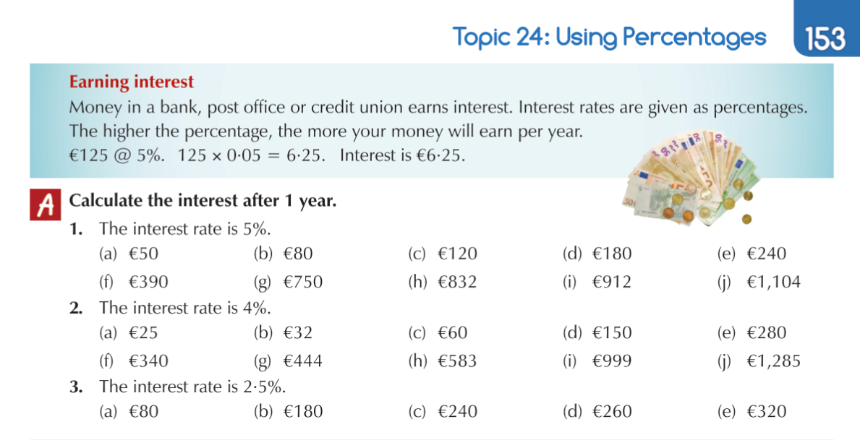

Gaeilge:
We are going to continue to focus on the verbs and vocabulary in Irish while we are not at school.
Knowing these very well before you go into secondary school will be of a great help to you.

- Go over the vocabulary on page 156 of the Abair Liom book and know these well by the end of the week. Below is a picture of this page for anybody who forgot to take their book home. Test yourself on these words at the end of the week to see how well you are learning them.
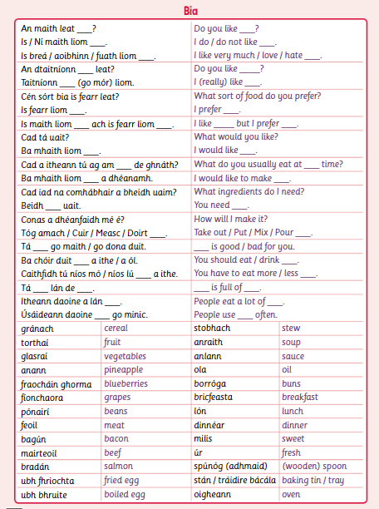

In relation to the verbs, we are going to go back over the irregular verbs for now and learn them well in all three tenses for all people i.e. mé, tú, sé, sí, sinn, sibh, siad.
These can be found on page 180 of the Abair Liom book. Below is a picture of the verbs we are going to be working on this week and some questions for you change into the correct tense.

This week we are going to focus on the following 2 verbs: Ith , Clois.
Please know the mé, tú, sé, sí, sinn, sibh, siad and the question for each of these verbs in all three tenses.

Test yourself at the end of the week to see how well you know these.
These will be very beneficial to you in secondary school.
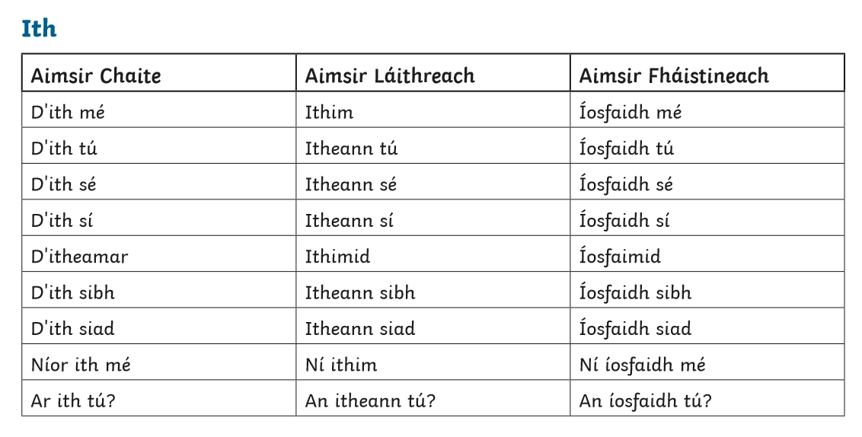
This picture below will help you identify the tense the verb should be in:
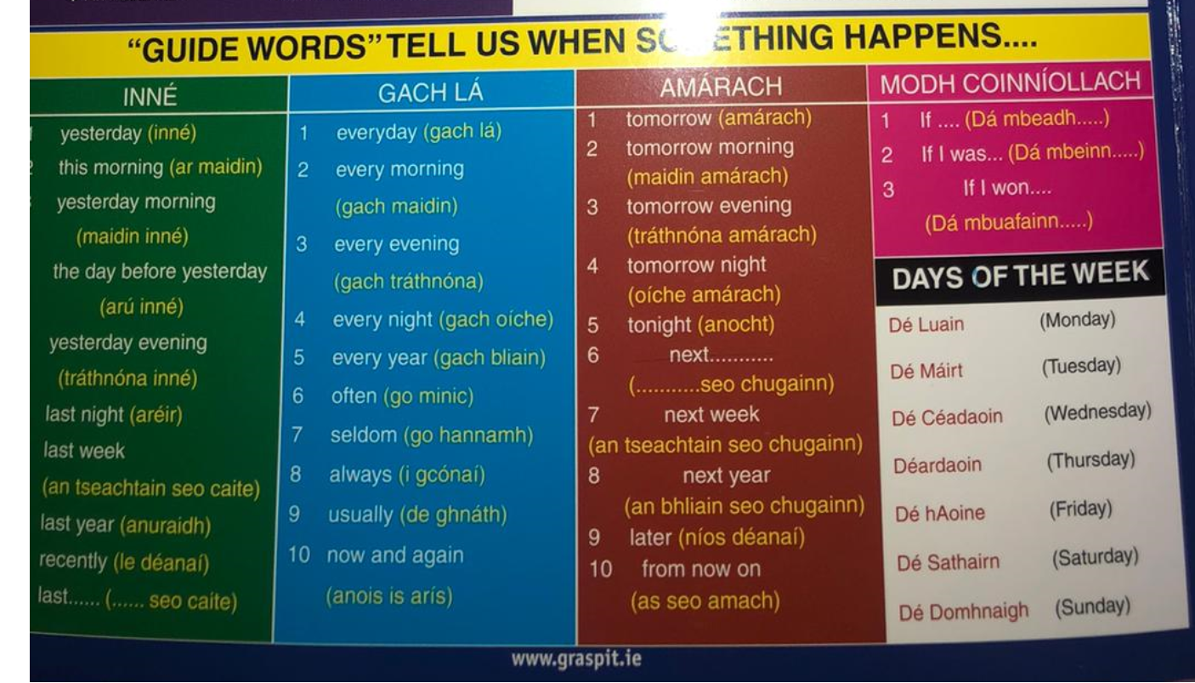
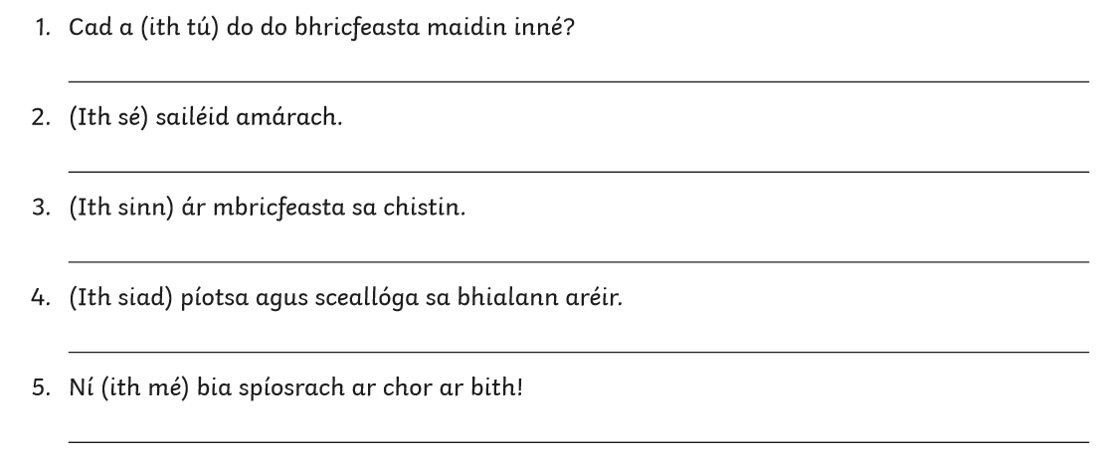

English:

- This week we’re going to work on the next chapter of Flying High.
- Please read the story ‘The Wonderling’ on pages 210 – 215.
- Complete the work on page 216 Qs 1-3 on both.

Below is a list of the spellings I want you to learn for this week:
- abandoned
- institution
- identified
- unclaimed
- innocent
- defined
- frightened
- fragment
- terrible
- brochure

History:
We will continue with our topic: 1916 and the Easter Rising.
Please re-watch the following link of the 1916 Easter Rising,
https://www.youtube.com/watch?v=rT8uFIbNrHw

After watching the video, please go to the CJ Fallon website and open the History Quest 6 Book (the same website you opened the geography quest book on last week)
https://my.cjfallon.ie/dashboard/student-resources
- Read pages 80 – 87 and answer questions 1-5 on page 87.

PE

- Go to the active school flag tab on our website for your PE activity.
- You can also do a Joe Wicks (The Body Coach TV) YouTube video, these are very good!

Well done on completing Monday!!


Tuesday
Maths:
We will continue with the Using Percentages chapter pages 153 - 154
Watch this YouTube video again to remind yourself of how to calculate simple interest.
https://www.youtube.com/watch?v=NCYNXkbTTUo
After watching the video, please complete:
- Page 153 Activities B
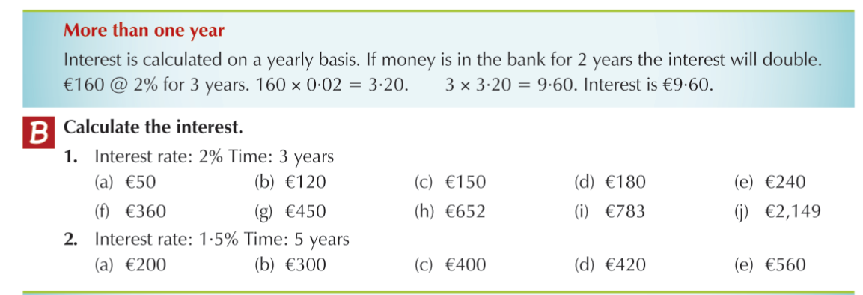

Gaeilge:
- Go over the vocabulary on page 156 of the Abair Liom book and know these well by the end of the week. Below is a picture of this page for anybody who forgot to take their book home. Test yourself on these words at the end of the week to see how well you are learning them.
- This week we are going to focus on the following 2 verbs: Ith , Clois
- Please know the mé, tú, sé, sí, sinn, sibh, siad and the question for each of these verbs in all three tenses.

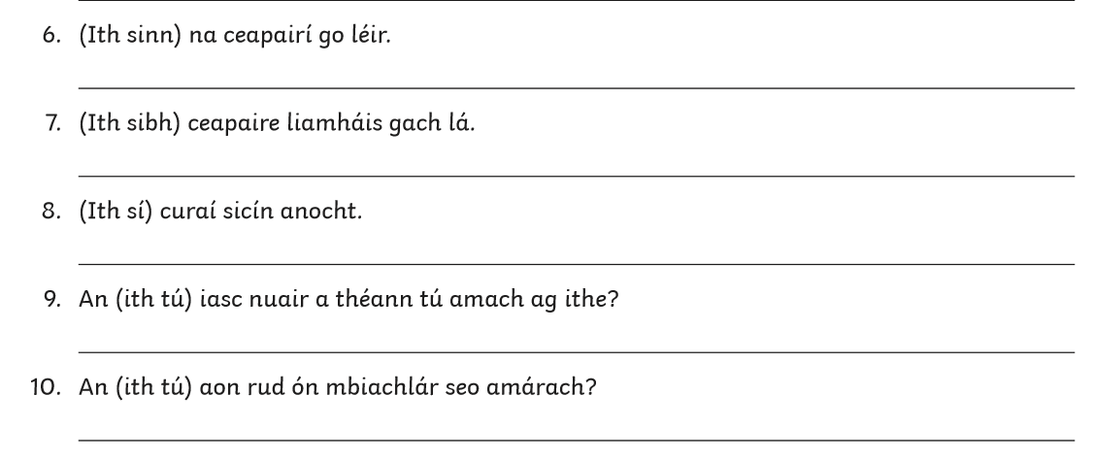
English:
- Please read back over the story ‘The Wonderling’ on page 210 - 215
- Complete the work on page 216 Qs 4-6 on both.

Below is a list of the spellings I want you to learn for this week:
- abandoned
- institution
- identified
- unclaimed
- innocent
- defined
- frightened
- fragment
- terrible
- brochure

Geography:
We are going to continue with our topic this week: The Burren in County Clare.
For this, you will need to access the Geography Quest 6 Book online. To do this follow these steps:
- Go to cjfallon.ie, you will see this:
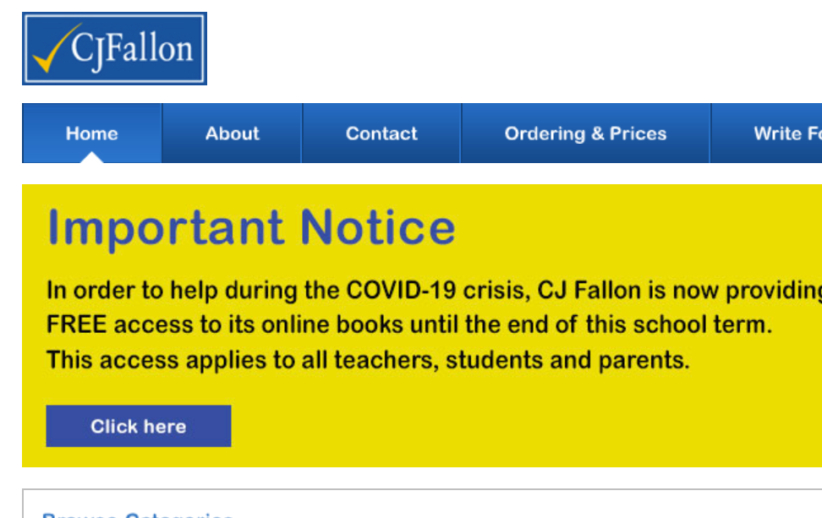

- Click on the ‘click here’ button which you can see above.
- You will be taken to a page with a grid, fill it out like this:
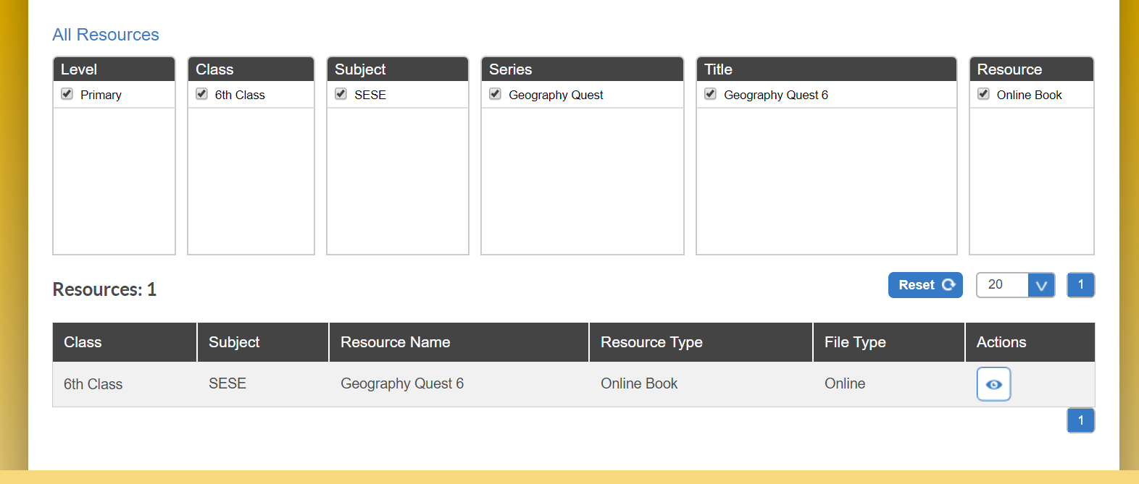
- Click on the ‘eye’ icon at the bottom right of the image above, this will open the book for you.
- Read pages 68 – 70 and answer the questions on page 70. (Questions 1 - 4)

PE

- Go to the active school flag tab on our website for your PE activity.
- You can also do a Joe Wicks (The Body Coach TV) YouTube video, these are very good!

Well done on completing Tuesday!!


Wednesday
Maths:
We will continue with the Using Percentages chapter pages 153 – 154.
Watch this YouTube video again to remind yourself of how to calculate simple interest.
https://www.youtube.com/watch?v=NCYNXkbTTUo
After watching the video, please complete:
- Page 153 Activity C
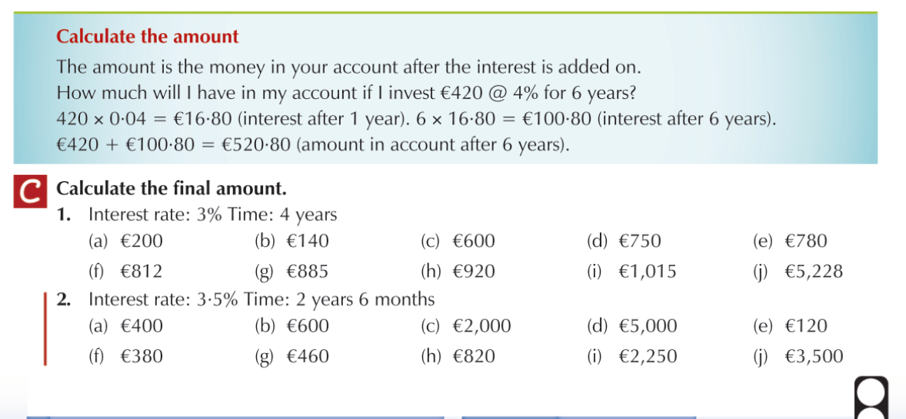

Gaeilge:
- Go over the vocabulary on page 156 of the Abair Liom book and know these well by the end of the week. Below is a picture of this page for anybody who forgot to take their book home. Test yourself on these words at the end of the week to see how well you are learning them.
- This week we are going to focus on the following 2 verbs: Ith , Clois
- Please know the mé, tú, sé, sí, sinn, sibh, said and the the question for each of these verbs in all three tenses.
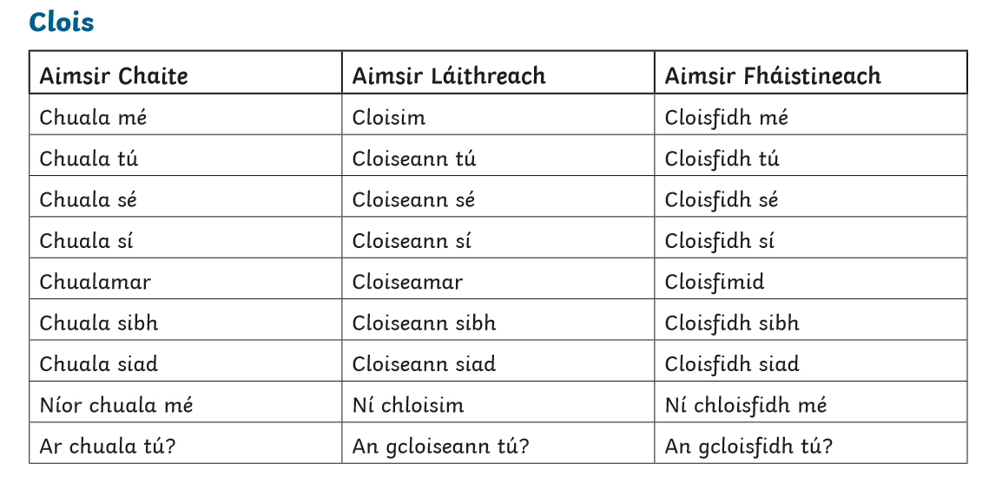
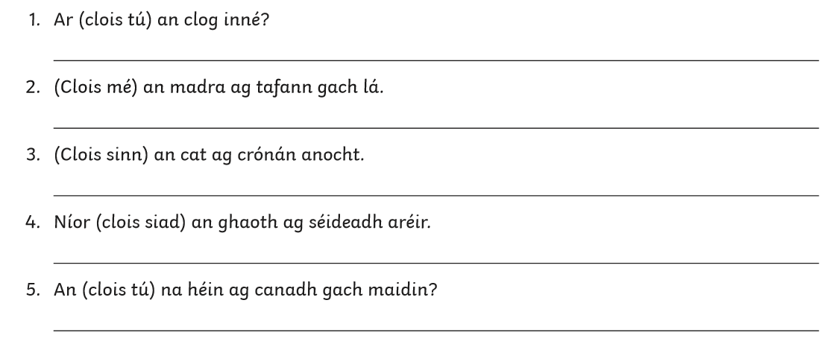

English:
- Please read back over the story ‘The Wonderling’ on page 210 – 215
- Complete the work on page 217 Activity D (Vocabulary)

Below is a list of the spellings I want you to learn for this week:
- abandoned
- institution
- identified
- unclaimed
- innocent
- defined
- frightened
- fragment
- terrible
- brochure

Science:
I hope you enjoyed learning about all the famous Irish scientists. This week I want you to pick a different scientist from the list below and fill out the scientist fact sheet.
Here are some scientists you may want to choose, you do not have to pick one of these:
- Jocelyn Bell Burnell

Kenneth Edgeworth

Robert Boyle

Kathleen Lonsdale

Ernest Walton

Francis Rynd

Francis Beaufort

You can research these scientists and many more at this website:

http://www.askaboutireland.ie/learning-zone/primary-students/subjects/science/science-full-story/famous-scientists/famous-irish-scientists/

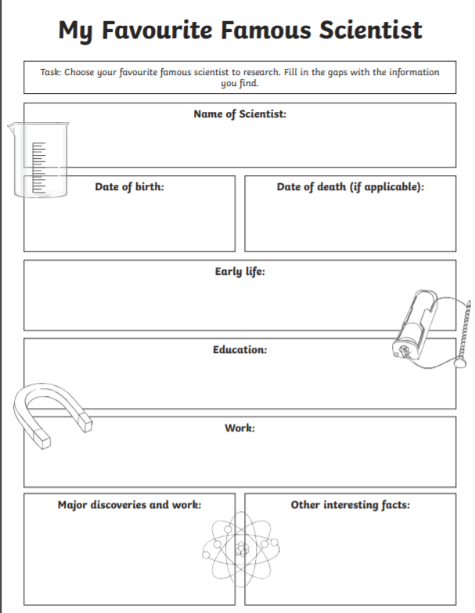

PE
- Go to the active school flag tab on our website for your PE activity.
- You can also do a Joe Wicks (The Body Coach TV) YouTube video, these are very good!

Well done on completing Wednesday !!


Thursday
Maths:
We will continue with the Using Percentages chapter pages 153 - 154.
Today we will look at the check-up for this chapter. To do this you will need to re-watch the link from the week before the Easter holidays on calculating percentage profit and percentage loss. Here is the link:
https://www.youtube.com/watch?v=FQhRiX5XaZ4&t=103s
Complete activity B on page 154.


Gaeilge:
- Go over the vocabulary on page 156 of the Abair Liom book and know these well by the end of the week. Below is a picture of this page for anybody who forgot to take their book home. Test yourself on these words at the end of the week to see how well you are learning them.
- This week we are going to focus on the following 2 verbs: Ith , Clois
- Please know the mé, tú, sé, sí, sinn, sibh, siad and the question for each of these verbs in all three tenses.
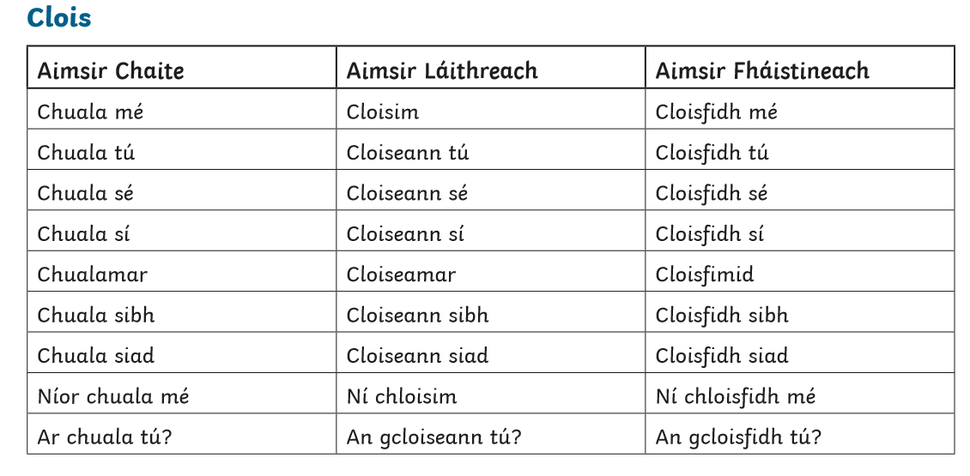
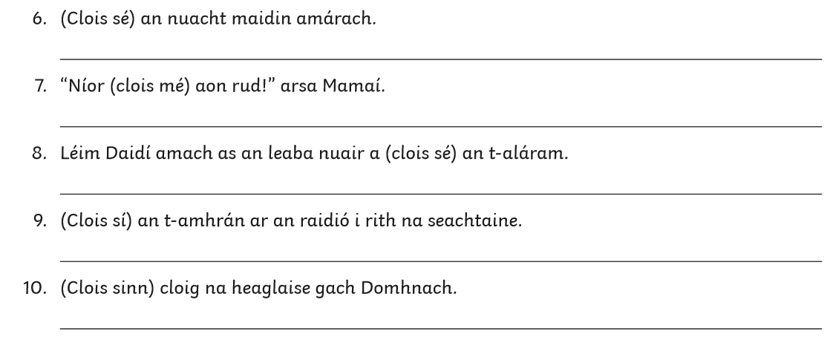

English:
Please see the extra document titled: “6th Class we are writers support resources” located on our website next to where you downloaded this document.
It explains your writing task for this week.
Below is a list of the spellings I want you to learn for this week:
- abandoned
- institution
- identified
- unclaimed
- innocent
- defined
- frightened
- fragment
- terrible
- brochure

Music:
GENRE – Classical music

https://www.youtube.com/watch?v=CVmvULWX_4Q

Listen to the link above and answer the following questions:

- Who composed this music?
- Why do you think this piece of music is called ‘The flight of the bumblebee?’
- How does this music make you feel? Why do you think that is?

PE
- Go to the active school flag tab on our website for your PE activity.
- You can also do a Joe Wicks (The Body Coach TV) YouTube video, these are very good!

Well done on completing Thursday!!


Friday
Maths:
Below is activity C from page 154. You have to calculate the percentage change in height of the airplane between each point.
For example, from point A to point B, the plane dropped 3,000 meters (9000 – 6000).
So I put 3000 over 9000 i.e. $\frac{3000}{9000}$ and simplify to $\frac{1}{3}$ and finally covert to a percentage, which is 33$\frac{1}{3}$%.
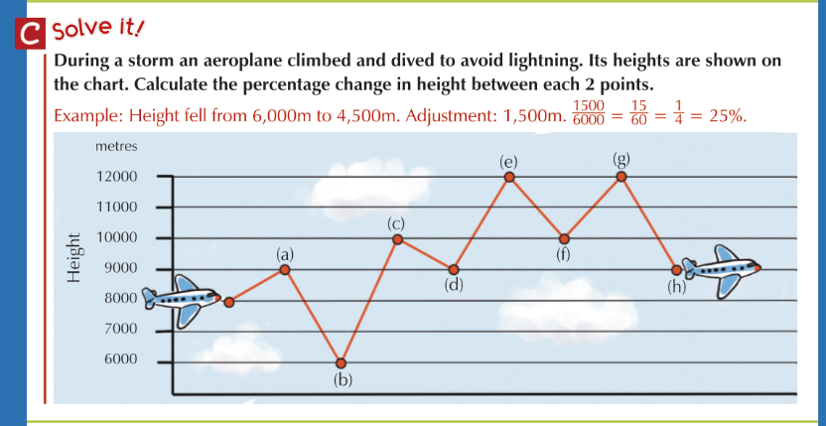

Gaeilge:
- Go over the vocabulary on page 156 of the Abair Liom book.

- Test yourself on these words today to see how well you are learning them.

English:
- Please read back over the story ‘The Wonderling’ on page 210 - 215
- Complete the work on page 217 Activity E (Grammar- Contractions)
Here are some links to help you with this:
https://www.youtube.com/watch?v=gubPH3WEurg
https://www.youtube.com/watch?v=5xE-vw2ctqo

Test yourself on these spellings:
- abandoned
- institution
- identified
- unclaimed
- innocent
- defined
- frightened
- fragment
- terrible
- brochure

Art
Here are a few mindfulness colouring sheets.
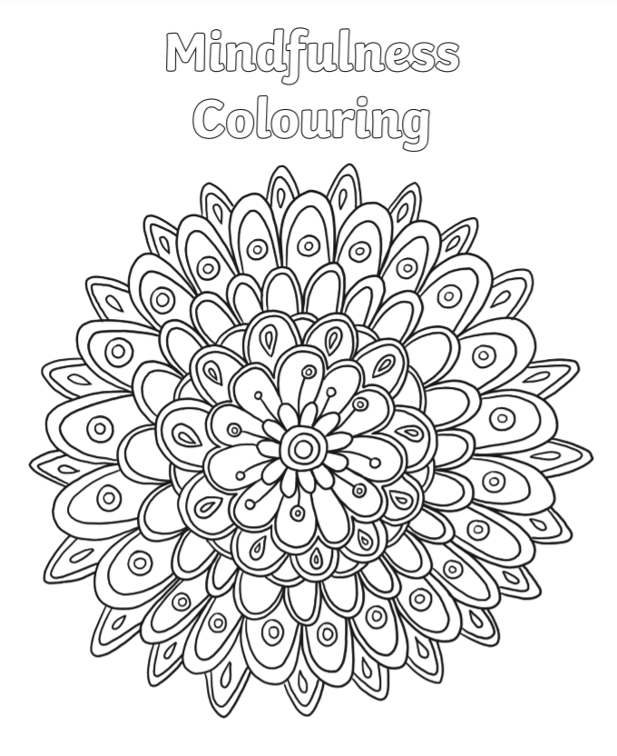
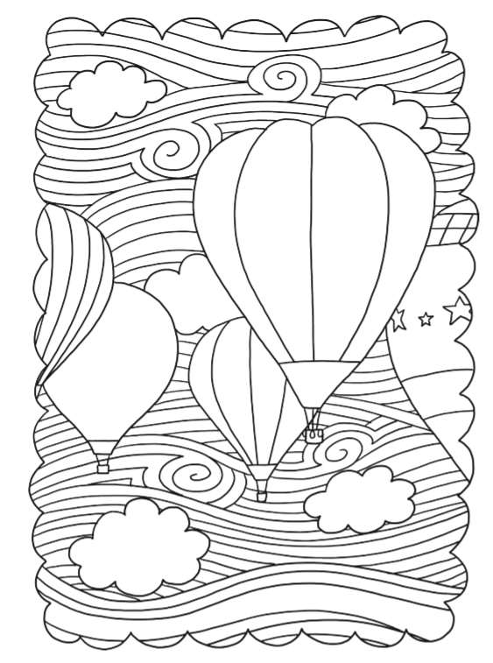

PE
- Go to the active school flag tab on our website for your PE activity.
- You can also do a Joe Wicks (The Body Coach TV) YouTube video, these are very good!

Well done on completing Friday and the full week!! Enjoy the weekend!
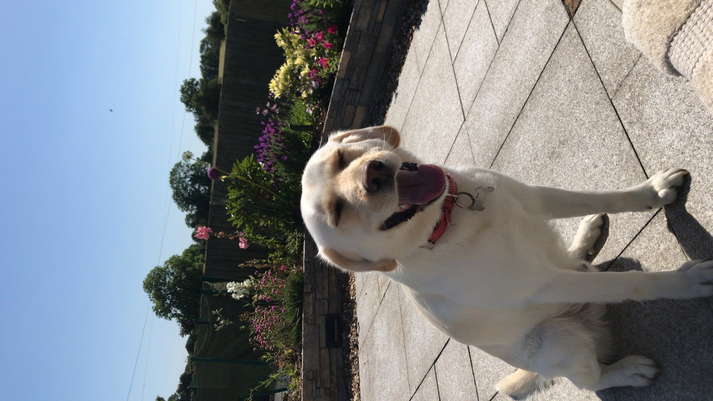
This is my dog, Cooper

