Hello 6th class,
I hope you all got on well with the work I set for you this week.
I have no doubt you tried your best with the work considering the circumstances!!
Below are the answers to that work. There are two pieces of work I cannot provide you with answers for. These are the science task and the creative writing task.
In relation to the answers, please keep in mind that some answers may vary. Once you get the same idea for your answer then that is fine, except in maths and the Irish verbs.

Hope you are all keeping well and have a lovely weekend.
Mr Carroll


Week 1  Day 1  English  Answers | A Q1 | The first name he remembered being called was Number Thirteen.
Week 1  Day 1  English  Answers | A Q2 | His eyes were a lovely chestnut brown colour.
Week 1  Day 1  English  Answers | A Q3 | His snout looked like a dogs snout.
Week 1  Day 1  English  Answers | B Q1 | People thought he was bad luck because of his one ear and his name Number Thirteen. Number thirteen is considered to be an unlucky number by many.
Week 1  Day 1  English  Answers | B Q2 | I think the tiny, old key might open a locked box with valuable possessions that belongs to him. I think this box may be hidden somewhere and he must find where it is. (You may have a different opinion for this question.)
 | B Q3 | I think the song may have come from somebody singing to him when he was very young, possibly his mother. (You may have a different opinion for this question.)
Week 1  Day 2  English  Answers | A Q4 | Number Thirteen was abandoned at an orphanage home called Miss Carbunkle’s Home for Wayward and Misbegotten Creatures.
Week 1  Day 2  English  Answers | A Q5 | The creature that appeared on the front of the home’s brochure was a happy-go-lucky creature with a head of a rabbit and the body of a little girl, wearing a polka-dot dress and a bow, clutching a bouquet of daisies.
Week 1  Day 2  English  Answers | A Q6 | Miss Carbunkle had the key to the heavy oak door.
Week 1  Day 2  English  Answers | B Q4 | I think the monastery was built in the shape of a cross because it was first used as a monastery which is a religious dwelling.
Week 1  Day 2  English  Answers | B Q5 | The sentence, “but none of the orphans ever saw a single flower or felt a blade of grass beneath their feet” tells us that the orphanage was a bleak and colourless place.
 | B Q6 | There are two sentences which tell us that Miss Carbunkle did not want anybody leaving the premises without permission, the first one: “To enter the orphanage itself, one had to pass through a heavy oak door, built into the wall and impossible to open without Miss Carbunkle’s brass key.  The second sentence: “there had been other doors built into the wall that surrounded the three-story building and grounds - … but Miss Carbunkle had sealed them off when she bought the place.  Both of these sentences tell us that Miss Carbunkle did not want anybody leaving the premises without permission.
Week 1  Day 3  English  Answers | Q1 | Furniture
Week 1  Day 3  English  Answers | Q2 | Signature
Week 1  Day 3  English  Answers | Q3 | Departure
Week 1  Day 3  English  Answers | Q4 | Moisture
Week 1  Day 3  English  Answers | Q5 | Posture
 | Q6 | Fracture
Week 1
Day 4
English
Answers
Week 1  Day 4  English  Answers |  | Creative Writing
Week 1  Day 5  English  Answers | Q1 | She’ll
Week 1  Day 5  English  Answers |  | Let’s
Week 1  Day 5  English  Answers |  | Who’ll
Week 1  Day 5  English  Answers |  | Can’t
Week 1  Day 5  English  Answers |  | Don’t
 |  | It’s
 |  | They’d
 |  | We’ve
 |  | You’re
 |  | Doesn’t
 | Q2 1 | Let’s go to the cinema…..
 | 2 | Don’t go outside…
 | 3 | It’s too late…..
 | 4 | She’ll have to show….
 | 5 | We’ve to bring…..
 | 6 | He can’t go to the rugby….

 | Q1 | The rising lasted for 5 days.
Week 1  History  Answers | Q2 | World War 1 began in 1914.
Week 1  History  Answers | Q3 | A number of volunteers were against fighting for Britain, they stayed at home under the control of Eoin Mac Neill who was against violence.
Week 1  History  Answers | Q4 | The IRB thought it would be an opportune time to take up arms against Britain because they knew many of the British soldiers would be off fighting in the war.
Week 1  History  Answers | Q5 | James Connelly founded the Irish Citizen Army.
Week 1  Geography  Answers | Q1 | The word Burren means bare rocky place.
Week 1  Geography  Answers | Q2 | The Irish word for Burren is boireann.
Week 1  Geography  Answers | Q3 | A turlough is important in winter as it attracts different types of flora and fauna to the area, it also takes the overflow of water from streams nearby.
Week 1  Geography  Answers | Q4 | Permeable means that water can seep through it quite easily.
Week 1
Science
Answers
Week 1  Science  Answers |  | Pick your own scientist

Maths  Week 1  Day 1  Answers |  | Pg153 A Q1 | 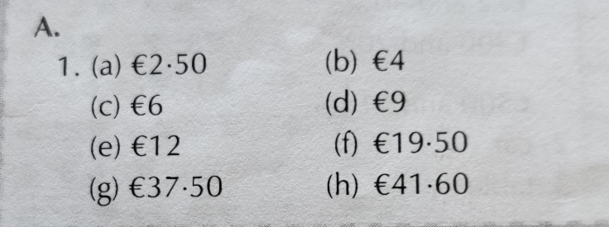
Maths  Week 1  Day 1  Answers |  | Pg 153 A Q2 | 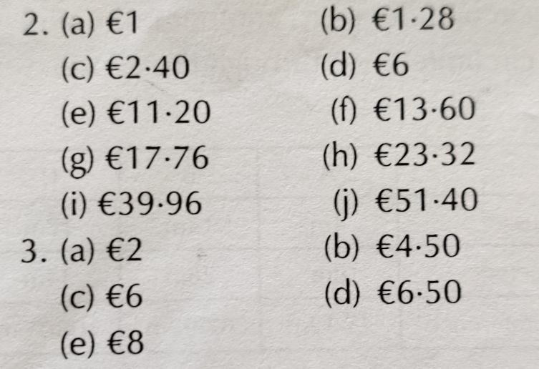
Maths  Week 1  Day 2  Answers |  | Pg 153  B Q1 & 2 | 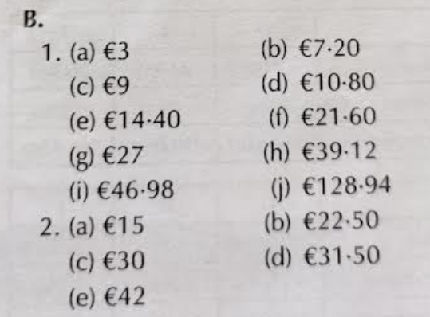
Maths  Week 1  Day 3  Answers |  | Pg 153  C Q1 & 2 | 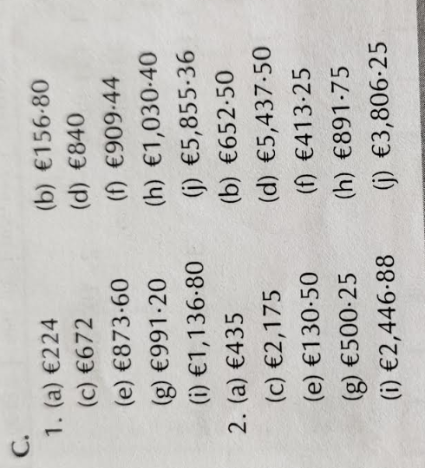
Maths  Week 1  Day 4  Answers |  | Pg 154 B | 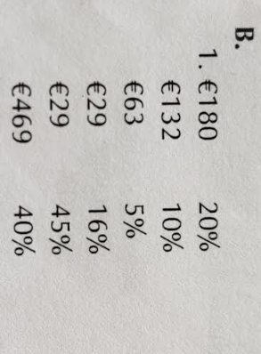
Maths  Week 1  Day 5  Answers |  | Pg154 C | 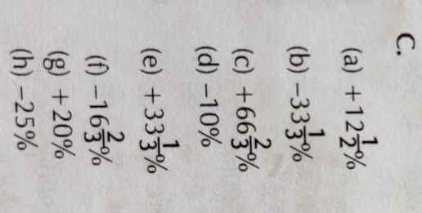

Gaeilge  Week 1  Day 1  Answers |  | 1. Cad a d’ith tú do do bhricfeasta maidin inné?  2. Íosfaidh sé sailéid amárach.  3. Ithimid ár mbricfeasta sa chistin.  4. D’ith siad píotsa agus sceallóga sa bhialann aréir.  5. Ní ithim bia spíosrach ar chor ar bith!
Gaeilge  Week 1  Day 2  Answers |  | 6. D’itheamar na ceapairí go léir.  7. Itheann sibh ceapaire liamháis gach lá.  8. Íosfaidh sí curaí sicín anocht.  9. An itheann tú iasc nuair a théann tú amach ag ithe?  10. An íosfaidh tú aon rud ón mbiachlár seo amárach?
Gaeilge  Week 1  Day 3  Answers |  | 1. Ar chuala tú an clog inné?  2. Cloisim an madra ag tafann gach lá.  3. Cloisfimid an cat ag crónán anocht.  4. Níor chuala siad an ghaoth ag séideadh aréir.  5. An gcloiseann tú na héin ag canadh gach maidin?
Gaeilge  Week 1  Day 4  Answers |  | 6. Cloisfidh sé an nuacht maidin amárach.  7. “Níor chuala mé aon rud!”, arsa Mamaí.  8. Léim Daidí amach as an leaba nuair a chuala sé an t-aláram.  9. Cloisfidh sí an t-amhrán ar an raidió i rith na seachtaine.  10. Cloiseamar cloig na heaglaise gach Domhnach.
Gaeilge
Week 1
Day 5
Answers
Gaeilge  Week 1  Day 5  Answers |  | Ag déanamh scrúdú

