Day 1  Irish  Answers | Q1 | Answers to game online
Day 1  Irish  Answers | Q2
Day 1  Irish  Answers | Q3
Day 1  Irish  Answers | Q4
Day 1  Irish  Answers | Q5
Day 1  Maths  Answers | Q1 | Task 1: 7
Day 1  Maths  Answers | Q2 | 23
Day 1  Maths  Answers | Q3 | 32
Day 1  Maths  Answers | Q4 | 49
Day 1  Maths  Answers | Q5 | 42
 | Q6 | 62
 |  | Task 2 : 13 50 31
Day 1  English  Answers | Q1 | 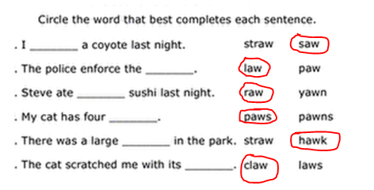  What other ‘aw’ words did you find? You might have found: jackdaw, draw, crawl, jaw, shawl, lawn, thaw, gnaw  If you wrote an ‘aw’ poem I hope you had fun. Well done!!
Day 1  Science  Answers | Q1 | Musical glasses  What did you notice?  I noticed that the more water there was in the glass the lower the pitch. The less water there was in the glass the higher the pitch.  The different levels of water in the glasses all made different notes and pitches.

Day 2  Irish  Answers | Q1 | Answers online for interactive game
Day 2  Irish  Answers | Q2 | 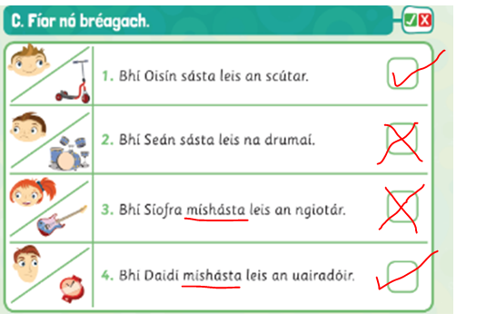
Day 2  Maths  Answers | Q1 | How many footballs has Jack left?  Draw 28 footballs.  Cross out 13.  There are 15 left.
Day 2  Maths  Answers | Q2 | - James has 31 sweets. He eats 19.  How many has he left?  Draw 31 sweets.  Cross out 19.  There are 12 left.
Day 2  English  Answers |  | - to look quickly ______________ (peek)  - a low area of land between hills or mountains___________ (valley)  - to pick up and move something __________(scoop)  - a metal bucket ________________(pail)  - the amount of money for something _______(price)  - measure things that are the same and different __________ (compare)
Day 2  Geog  Answers | Q1 | 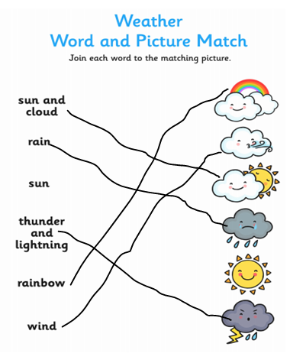I hope you did well on your weather journal. Ask an adult to check it for you.

Day 3  Irish  Answers | Q1 | Comhrá/ rólimirt: I hope you had fun with this. Check your comhrá online again if you are finding any words tricky to read or say.
Day 3  Maths  Answers | Q1 | 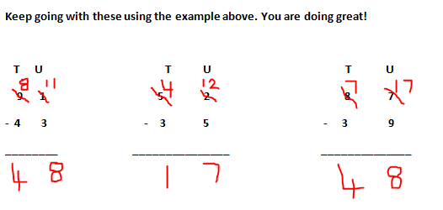
Day 3  Maths  Answers | Q2 | 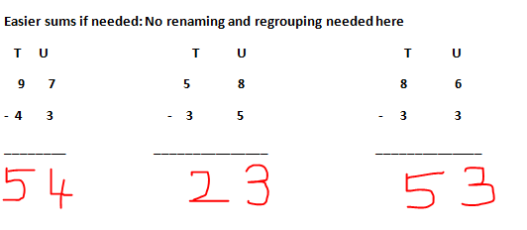
Day 3  English  Answers | Q1 | The poem tells us that the cheese we eat comes from the moon.
Day 3  English  Answers | Q2 | The mice collect the Wensleydale cheese by scooping it into metal pails.
Day 3  English  Answers | Q3 | The mice wear spacemen hats.
Day 3  English  Answers | Q4 | Did you like this poem? There is no right or wrong answer here. It is your own opinion. The important thing is that you give a reason for your answer.  Here is my answer: Yes, I did like this poem because, firstly, I love cheese of all kinds and also because the poem helped me create lots of funny images in my mind about how the mice collect cheese from the moon. It is a fun and creative poem and I found it very entertaining. My favourite verse was the final verse where the poet described the mice wearing spacemen hats. This is a very funny image.
Day 3  English  Answers | Q
Day 3  PROJECT DAY |  | PROJECT DAY!!  What topic did you decide to do your project on?  What sub- headings will you do?

Day 4  Irish  Answers | Q1 | Task 1: Rólimirt/comhrá
Day 4  Irish  Answers | Q2 | Task 2: Féach ar an leoraí. ( Look at the lorry. )
Day 4  Irish  Answers | Q3 | Tá an teidí go deas. ( the teddy is lovely.)
Day 4  Irish  Answers | Q4 | Is breá liom mo ghiotár. ( I love my guitar. )
Day 4  Irish  Answers | Q5 | Cé mhéad atá ar an scútar? ( How much is the scooter?)
Day 4  Maths  Answers | Q1 | 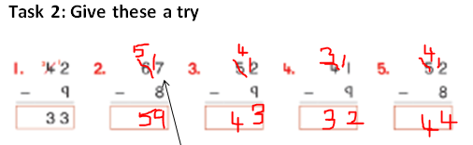
Day 4  Maths  Answers |  | 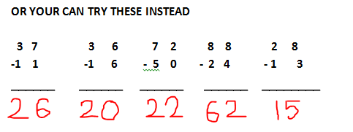
Day 4  English  Answers | Q1 | ‘A trip to the moon’ poem or story. Ask an adult to check for Capital letters, full stops and any spelling mistakes that could be fixed. Did you use any good adjectives this week to describe the rocket or the moon?
Day 4  Music  Answers | Q1 | high
Day 4  Music  Answers | Q2 | low
Day 4  Music  Answers | Q3 | low

Day 5  Irish  Answers | Q1 | 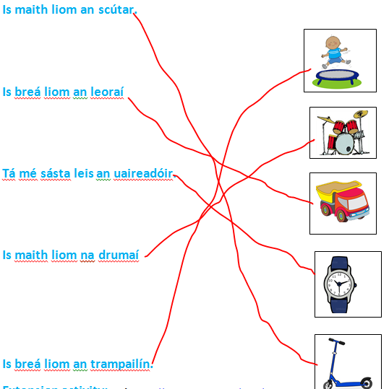
Day 5  Irish  Answers | Q2
Day 5  Irish  Answers | Q3
Day 5  Irish  Answers | Q4
Day 5  Irish  Answers | Q5
Day 5  Maths  Answers | Q1 | 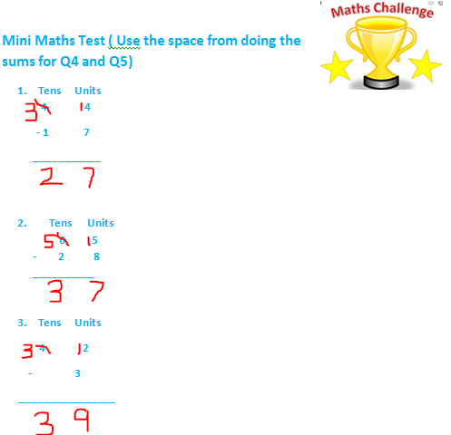
Day 5  Maths  Answers | Q2
Day 5  Maths  Answers | Q3
Day 5  Maths  Answers | Q4 | T U  2 2  -1 5  0 7 Adam had 7 sweets left.
Day 5  Maths  Answers | Q5 | T U  4 4  - 1 7  2 7 There were 27 birds left.
Day 5  English  Answers | Q1 | SPELLING TEST- ADULT TO CHECK YOUR TEST.
Day 5  Art  Answers | Q1 | I hope you had fun making your rocket. You can go and visit those mice on the moon now!!

