Hi Everyone,
We hope you had fun with your art projects last week and the children engaged in the activities. We have been so lucky with the lovely weather. Having your child outside playing and exploring in the garden, going for walks to the park and if you’re lucky, the beach are great ways to engage your children and incorporate all the learning skills that we have been posting since the school has had to close. We are really sad that we don’t get to see your children again this academic year. Feel free to send pictures to the school email address st.colmcilles1@gmail.com and we can add them to their Learning Journals. Just put for the attention of Bernie or Kelly in the subject box!
Wishing you all the best and we hope you are all getting on ok at home.
Bernie and Kelly 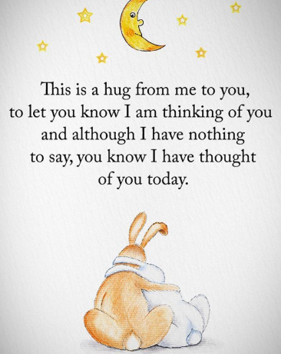
Songs of the Week:
Barney “we take turns” https://www.youtube.com/watch?v=NwchTts5U-4
“Wait your turn” https://www.youtube.com/watch?v=gnZPBaWhiqo
The Higgaloos “Taking turns” https://www.youtube.com/watch?v=tEGdCLkYcQs
Story of the week:
“It’s my turn” https://www.youtube.com/watch?v=xJBk9mJwkeI
Captain MacFinn “taking turns” https://www.youtube.com/watch?v=vPYsLtal10Y

The Theme of the week: Taking Turns
Mary our wonderful SNA has created a video for this week to help explain and to give visual examples to the children of what turn taking is all about. With all our videos once you click on the link just enter the password Wrens2020 and it will load straight up.
We hope they enjoy!
https://vimeo.com/user110523111/download/422718844/bd133d967a
Most people agree that learning to take turns is crucial to success in social situations. What often goes unappreciated is how turn taking involves the mastery of several related skills that are likewise important throughout life.
For instance, the ability and willingness to take turns involves
- the skill of waiting (impulse control),
- the ability to read facial expressions and body language (social perception) and
- the twin skills of sharing and conversational reciprocity (the dance of interactions).
How we teach turn taking depends on a person’s developmental level. For example, young children and children with autism may not be able to process a lot of verbal instruction. In these situations, it’s important to create an environment that encourages and supports turn taking.
Learning how to take turns along with its related skills is a lot like learning to read. As the child masters each level, we want to build on the skill while practising it in different situations.
Here are some strategies we’ve found helpful working with children of different ages and developmental levels.

Taking turns in games
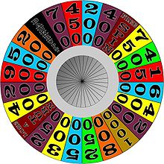
Many games and other fun activities lend themselves to learning how to take turns. We recommend games that have a clear turn taking structure combined with a strong visual element. Good examples include games with turns that involve rolling dice, spinning a wheel, picking up a card and so on.
You may find it helps to use visual supports as a reminder or signal for when it’s someone’s turn. For example, consider giving each player a card that’s red on one side and green on the other. You might explain that players keep their cards with the red side up while waiting, then flip it to green when it’s their turn.
At first, the person learning to take turns may need some assistance. For instance, if your child reaches for the spinner out of turn, you can point to the red card and say “Wait” or ask “Whose turn?”
Remember to praise your child for waiting their turn. Depending on the situation, you might also give a sticker or other small reward.
A turn taking project
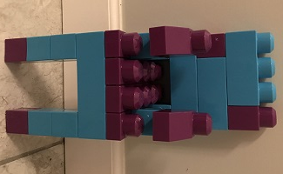
Lego is a great tool to encourage turn taking, in a building game involving two partners. We provided a picture of a completed structure built from blocks of two different colours. The structure can be as simple or complex as you judge appropriate. Give one partner all the blocks of one colour – let’s say red. Give the other colour – let’s say blue – to the other partner. Now invite them to build the structure by taking turns.

Structured sharing

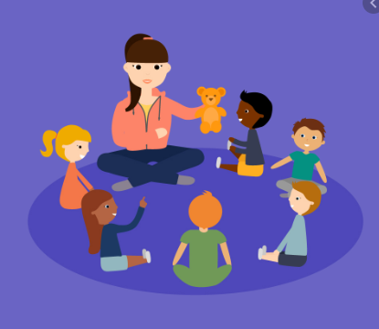
While the children were still attending school they all participated in daily time for sharing. The children would sit in a circle, and were presented with fun toys, some would light up, some would make noises and others could be wound up. This was a wonderful opportunity to learn the routine of turn taking, as each child learns to not only wait but also to focus on others. This would be a very easy activity to incorporate at home. If you gather up your child’s favourite toys and put them in a box or a bag, present the toy to the child one at a time and make sure you have a turn playing with it before giving it to your child. Using simple language such as “waiting”, “your turn”, “my turn” will work really well here to encourage patience. The key to success is repetition as part of the child’s daily schedule.
As in game playing, you can use red- and green-sided cue cards as visual supports to help your child remember to wait their turns. To signal when your child’s turn is over, you could use a timer or give a verbal or visual cue. For example, hold up a yellow card, followed by a red card.

Turn taking and table manners

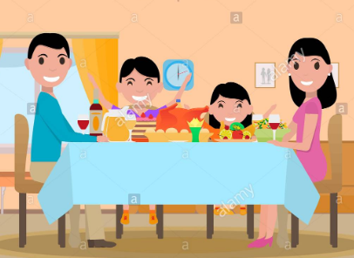
Of course, turn taking is also important when it comes to serving food. Here again, you can use the red- and green-sided cards. Everyone starts with the red side up. Then one at a time, each person turns the card to green when the cook signals it’s their turn to serve themselves. This can be done with sharing out a packet of sweets or biscuits having your child give one to everyone at the table before they eat one themselves.
Again, be ready to remind your child if they start to go out of turn, pointing to the red card and calmly asking, “Whose turn?” or saying, “Wait, please.” Likewise, remember to use lots of positive reinforcement such as immediate praise for waiting and perhaps a sticker or small prize.
As these examples illustrate, it’s helpful to use the same or similar cues across different activities and settings. The consistency can speed learning and help a child apply the skill in new and unanticipated situations.
You might even keep a couple of those green- and red-sided cards in a pocket or purse for situations like waiting in line at a store or for a server to take your order in Mc Donald’s or at a restaurant. (If we are lucky enough to eat out in the near future.)
Here is a visual aid that you can print out and use to support you in teaching your child about turn taking.