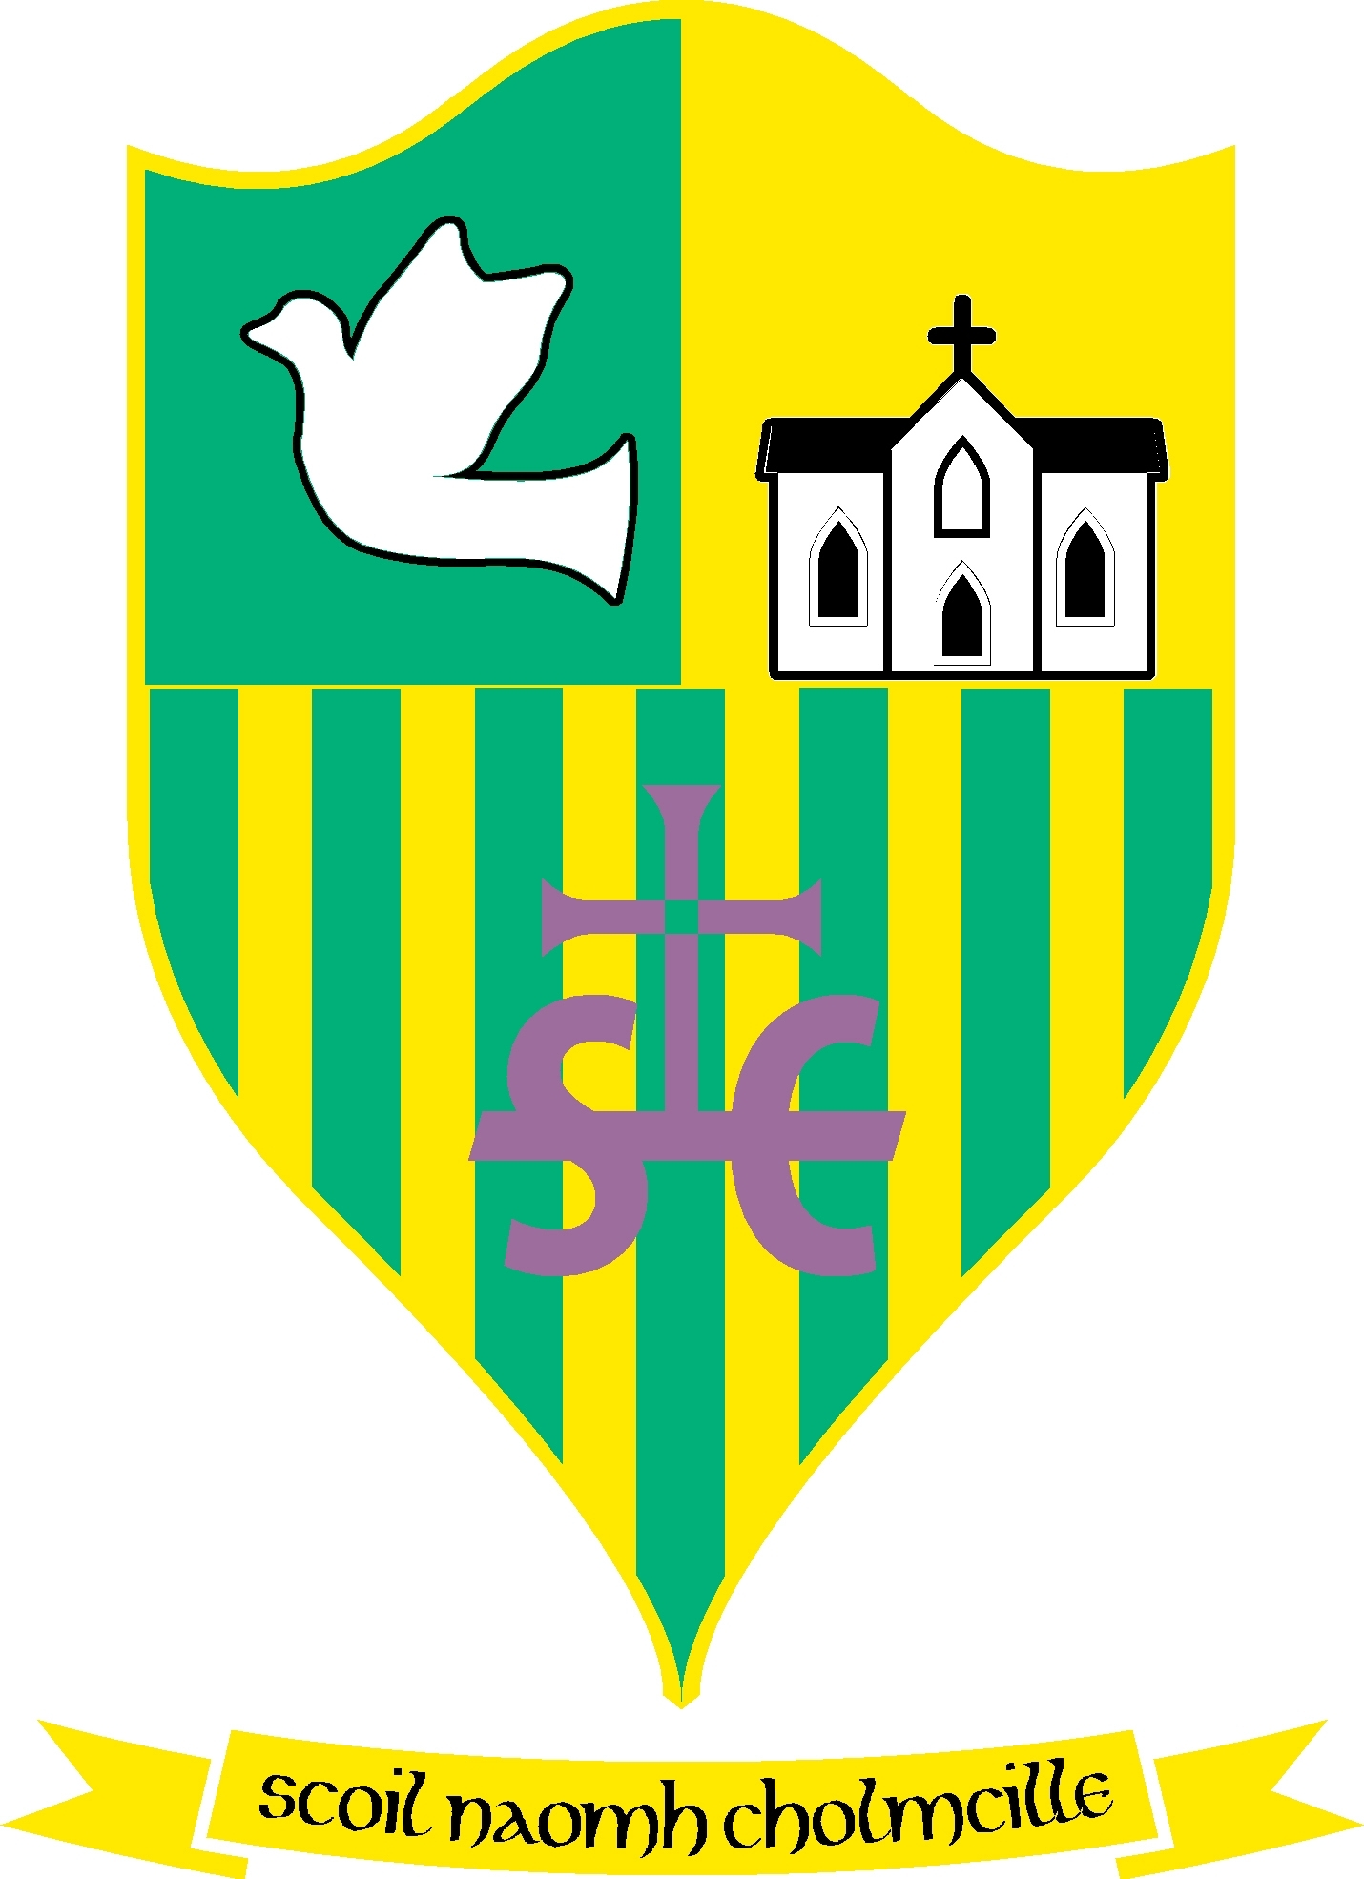
Scoil Naomh Cholmcille

Scoil Naomh Cholmcille

Tullydonnell, Togher, Drogheda, Co. Louth. Ph :041-6852301 Email:st.colmcilles1@gmail.comRoll no 01434O
Dominus illuminatiomea

7th August 2020
Dear Parents,
We are happy to confirm that the Confirmation ceremony is scheduled for the 14th of August. Due to the restrictions remaining the same and in order to accommodate everyone as best we can there will be 4 services for Tullydonnell school. Both parents and sponsor (if not the parent) may attend along with the child making their Confirmation.
5th Class will be split into two groups one service at 11am followed by a second service at 12pm. The church will be serviced by the Covid Committee in the interim of each service to ensure that it is ready for the next party.
6th Class will be split into two groups one service at 1pm and followed by a second at 2pm. Again the Covid Committee will have the church ready in the interim of the two services.
The Confirmation service will be shorter than the usual Confirmation Mass. There will now be no participation from the Confirmandi in terms of readings or prayers of the faithful as was originally planned.
Face masks should be worn where at all possible by all adults attending the ceremony.
A Covid Form must be filled out by all parties attending the ceremony. Please download this form for each member of your party and fill it out. Return these forms in one email to the school three days before the confirmation, ie by Tuesday of next week. There will be a contact tracing form in the church on the day of the service as well.
You will receive a text message today indicating the time your family should attend the church.
On the day please wait in your car until you are asked to enter the church.
We are really looking forward to the day and we hope it will be a lovely memorable occasion for your child and you the parents.
Kindest regards, AM Ford N. Carroll J. Cotter

