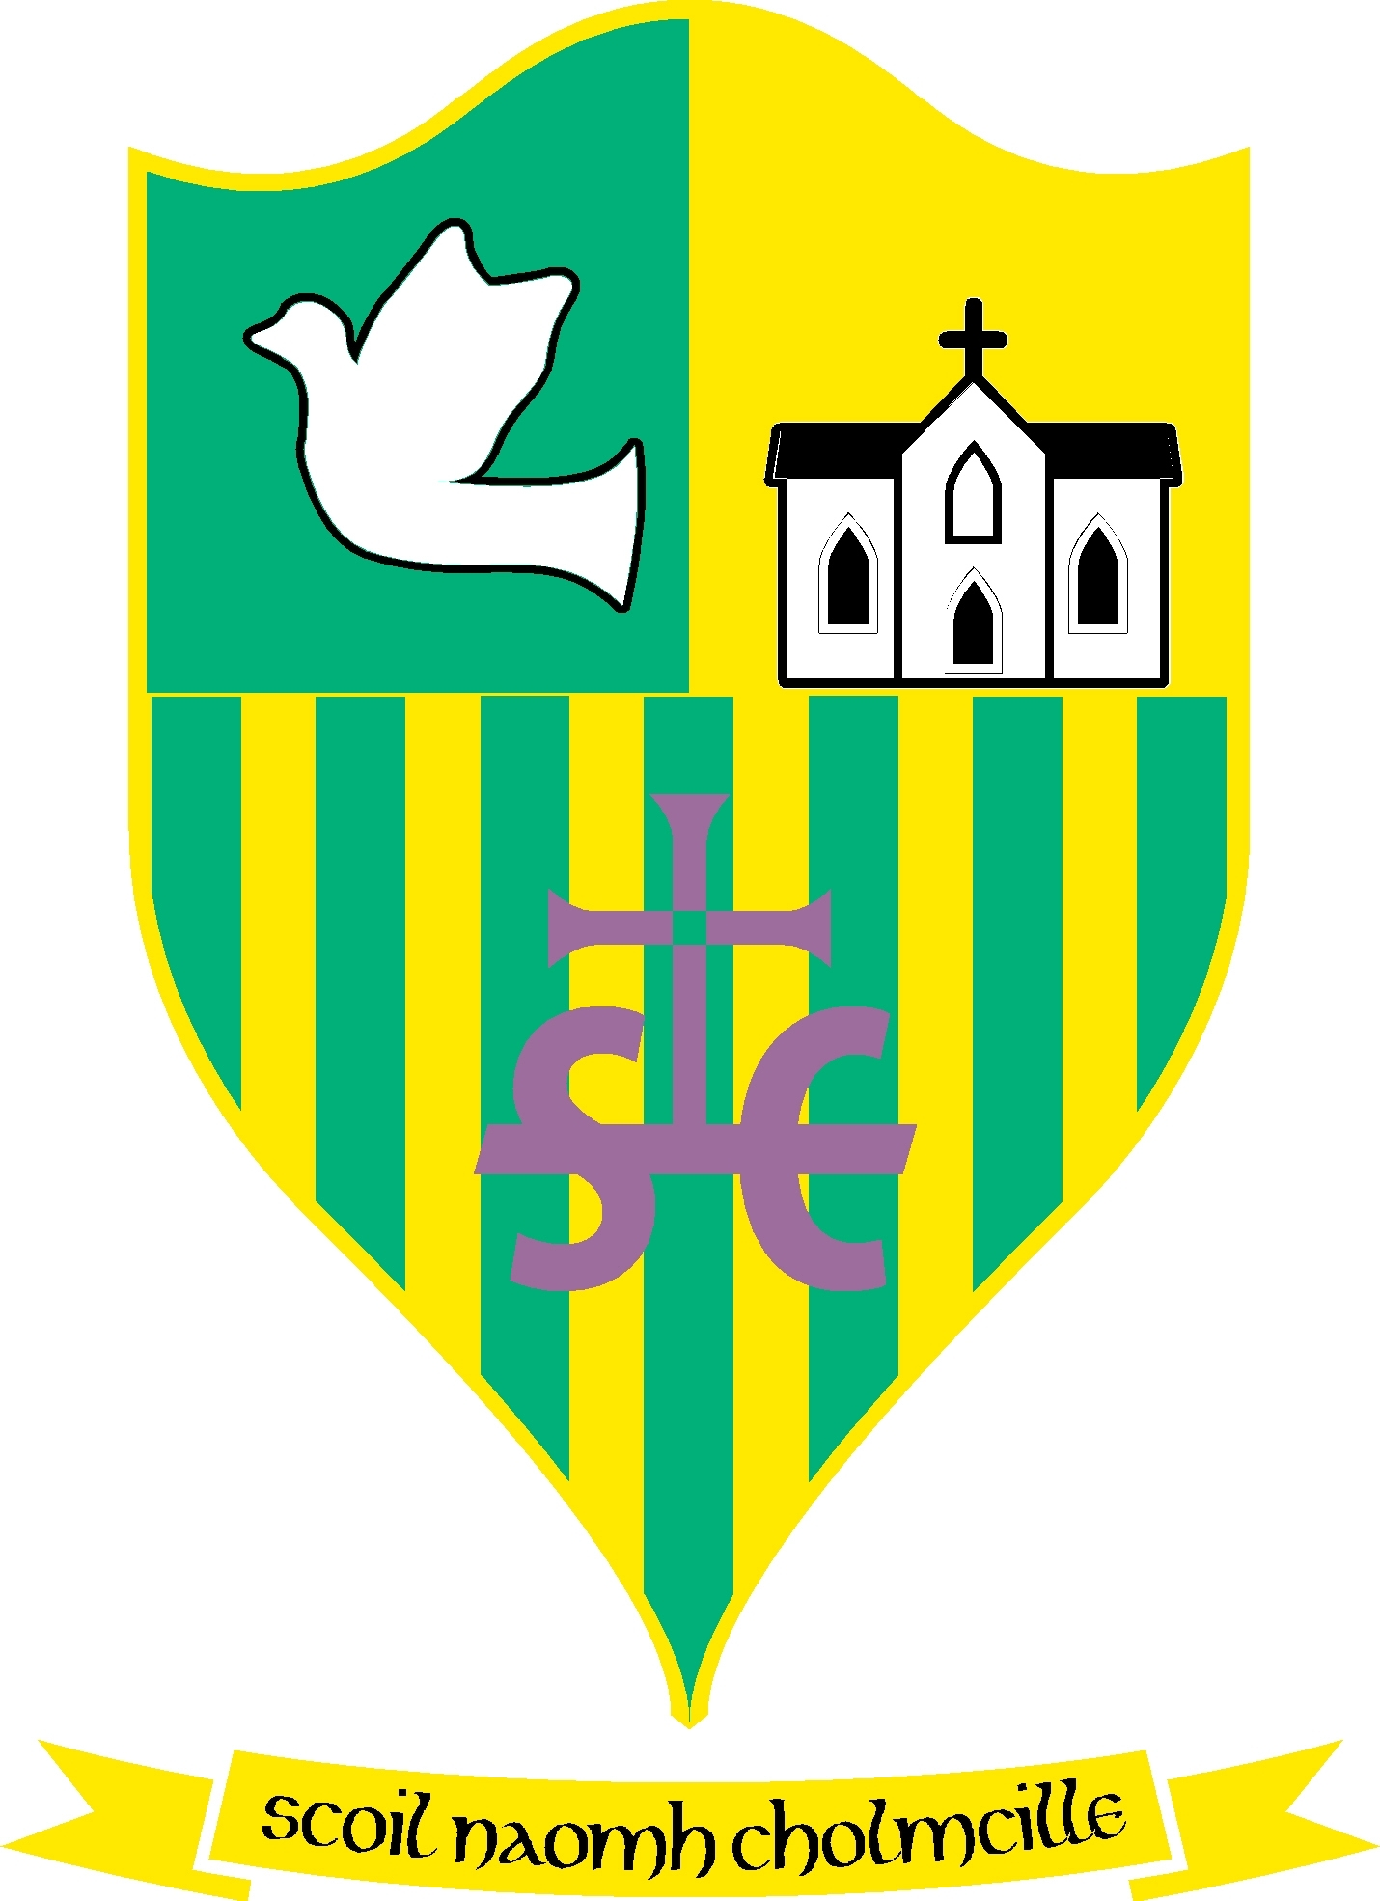
Scoil Naomh Cholmcille

Scoil Naomh Cholmcille

Tullydonnell, Togher, Drogheda, Co. Louth. Ph :041-6852301 Email:st.colmcilles1@gmail.comRoll no 01434O
Dominus illuminatiomea

7th August 2020

6th Class Graduation Ceremony
The Graduation Ceremony for 6th class will take place in the school grounds after the last service for Confirmation. There will be a one- way system in place to enter and leave the grounds and separate pods for each group for health & safety of all. We would ask everyone to adhere to the protocols put in place in order to keep everyone safe. Siblings of the Confirmandi may attend the Graduation Ceremony if they so wish, however we cannot accommodate extended family.
We are really looking forward to this special occasion, it’s been a long time coming!
The covid form submitted will suffice for all who attended the Confirmation. Please fill out the covid form for any extra siblings attending the Graduation ceremony and attach them in the one email.
We thank you for your support in this matter. It’s very different times but our main aim is to keep everyone safe! Looking forward to seeing you all next Friday.
Kindest regards,
AM Ford N. Carroll.

